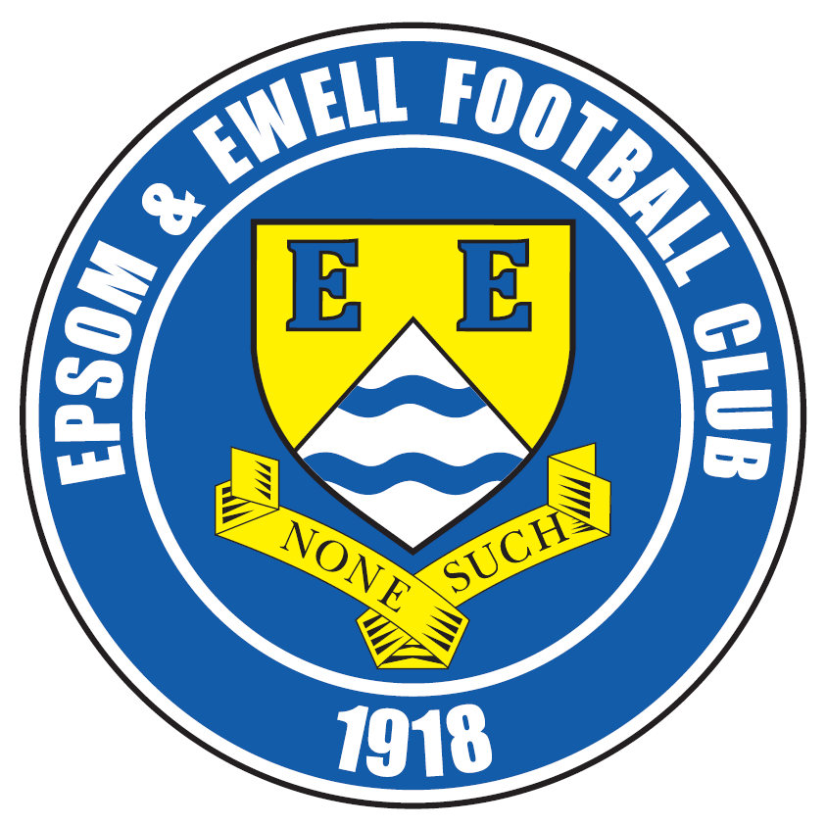 | Epsom & Ewell F.C.  25  v  Westfield F.C.  Friday, 25th March 2016 – 1.00 p.m.
Good afternoon! We welcome the players, supporters and officials of Westfield Football Club for a League match, together with today’s match officials, our own regular supporters and any new or occasional visitors today. We also thank Westfield for agreeing to our request on the change of date. We believe that by playing on a Friday instead of the Saturday, it will benefit both clubs by giving them an extra day between this match and the Easter Monday matches. We’ll both find out soon whether this has worked!

We met at Woking Park back in September and had an excellent result there. In fact, after 3-0 and 4-0 defeats on our previous visits, the goalless draw we secured was a vast improvement!! In all seriousness, I felt we were a little unfortunate not to win in the end, considering we had a very dubious “offside” goal from Kyle Hough ruled out near the end and had played much of the second half with ten men after Matt Ferdinando was harshly sent off. Maybe it is just as well he is not playing today, as he was sent off in our last two matches against today’s opponents!

Although not the case for as many clubs as you might think, we have a much better record against Westfield at home and all nine of our previous home meetings have been won by our boys, so no pressure today lads!

We were last in action here ten days ago when Cove were our visitors, and were very fortunate to secure the points, requiring a 91st minute Matt Farrell header to win 1-0. We then suffered another postponement at Chessington & Hook United on Saturday. Intriguingly the League have not yet set a new date for this match and we were aware that the League had told them that they needed to play us on that date, so it will be interesting to see what happens next.

Then on Tuesday we made one of our longest journeys of the season to Farnham Town, where another late winner, this time from Bentley Graham, earned us a 2-1 win in a game where we bossed matters but struggled to break the opposition down. Tom Neale scored our first goal.

On Monday, we visit Raynes Park Vale with the traditional 11.30 start and then on Saturday 2nd April we visit Guildford City, where Steve Dyke and his band of fund raisers are aiming to break the world record for the longest ever conga! As you do!! This is intended to start at 12.00 so if you are interested in completing 16 laps of the track at The Spectrum in a happy party mood, Steve will be happy to see you, and if you can raise any funds for MENCAP then of course he will be pleased to give you further details. We return here for a home match against Badshot Lea on 9th April.

Enjoy the game!

Rich

Quick Question: When did we last play on a Friday? Answer revealed later on!

You can now follow us on Facebook: www.facebook.com/epsomandewellfc Twitter: @EEFCOfficial
and on Instagram at: www.instagram.com/epsomandewellfc

Cover Photos by Gemma Jarman

- Our defender turned keeper Dan Dean saves a penalty v Knaphill on 12th March
- James Taylor crashes in a far post header to put us ahead in that same match


Cherry Red Records Combined Counties League
Premier Division Table 2015/16
inc Tuesday 22nd March | P | W | D | L | F | A | Pts | GD | H | A
Hartley Wintney | 31 | 26 | 2 | 3 | 94 | 29 | 80 | +65 | 0-1 | 3-3
Ashford Town (Mx) | 34 | 25 | 2 | 7 | 91 | 45 | 77 | +46 | 30/4 | 3-2
Epsom & Ewell | 33 | 20 | 8 | 5 | 74 | 35 | 68 | +39 | - | -
Camberley Town | 30 | 20 | 5 | 5 | 63 | 26 | 65 | +37 | 16/4 | 1-1
Horley Town | 32 | 16 | 7 | 9 | 70 | 44 | 55 | +26 | 3-4 | 2-2
Hanworth Villa | 34 | 17 | 4 | 13 | 61 | 53 | 55 | +8 | 5-0 | 23/4
Spelthorne Sports | 36 | 15 | 9 | 12 | 69 | 64 | 54 | +5 | 2-1 | 6-2
Colliers Wood United | 36 | 16 | 5 | 15 | 71 | 66 | 53 | +5 | 3-1 | 3-0
Guildford City | 35 | 15 | 6 | 14 | 68 | 72 | 51 | -4 | 4-0 | 2/4
Knaphill | 30 | 15 | 3 | 12 | 67 | 48 | 48 | +19 | 1-2 | 1-1
Raynes Park Vale | 32 | 15 | 3 | 14 | 65 | 65 | 48 | 0 | 3-1 | 28/3
Windsor | 35 | 12 | 8 | 15 | 60 | 70 | 44 | -10 | 2-2 | 1-2
Farnham Town | 30 | 12 | 5 | 13 | 56 | 50 | 41 | +6 | 1-0 | 2-1
Bedfont Sports | 34 | 11 | 8 | 15 | 55 | 50 | 41 | +5 | 1-0 | 2-2
Badshot Lea | 33 | 13 | 1 | 19 | 48 | 83 | 40 | -35 | 9/4 | 1-0
AFC Hayes | 33 | 11 | 6 | 16 | 51 | 65 | 39 | -14 | 1-1 | 12/4
Chertsey Town | 34 | 10 | 7 | 17 | 49 | 61 | 37 | -12 | 0-1 | 5-3
Sutton Common Rovers | 33 | 11 | 4 | 18 | 56 | 73 | 37 | -17 | 3-1 | 2-1
Westfield | 29 | 10 | 6 | 13 | 38 | 53 | 36 | -15 | - | 0-0
Chessington & Hook | 27 | 7 | 2 | 18 | 42 | 70 | 23 | -28 | 1-0 | -----
Redhill | 29 | 5 | 4 | 20 | 41 | 67 | 19 | -26 | 3-0 | 1-0
Cove | 34 | 2 | 1 | 31 | 25 | 125 | 7 | -100 | 1-0 | 7-0

Lucky Day? – 25th March
Played 12 - W 6 D 1 L 5 - F 17 A 24 - PPG 1.58 - Above Average
Our Club record against Westfield
Played 17 - W 11 D 3 L 3 - F 39 A 27 - PPG 2.12 - Very Good
Largest wins and losses against Westfield
21st October 1967 - W 6-1 - Amateur Cup Second Qualifying Round (H)
31st October 1964 - L 1-5 - Surrey Senior Cup Second Qualifying Round (A)
Their Last Visit
Tuesday 24th March 2015 - W 3-1 - Combined Counties League

Club Manager – Glyn Mandeville
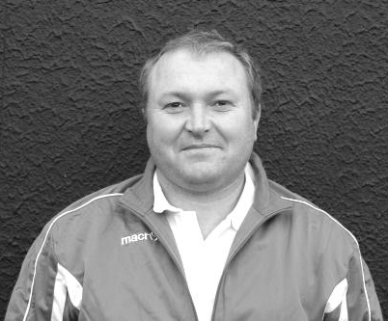
Good afternoon and welcome to High Road for our match against Westfield.

We come into today's game after winning our last couple of matches. Whilst we all admit we've not played that well as a team, we have worked very hard to win them.

We face a very tough team in Westfield today and hope we all turn up with the right mindset as we will need to be at our best if we are to beat today's opposition.

I hope you all enjoy today's game and have a great Easter weekend and have a safe trip home.

Manders

Club Captain - Sam Currie

Good afternoon and welcome to High Road for this afternoon’s game with Westfield. We welcome the squad, management team and their supporters for what should be another tough game.

As with previous games against Cove and Farnham on Tuesday, the teams within the middle and nearer the foot of the table sometimes give us a harder test and within the last two games we have had to find perhaps different ways to break teams down and get the results.

With a near enough full squad for the Gaffa to choose from we are in a good place and we know the competition for places are high and therefore there is a good buzz in the squad, but most importantly with the three games in quick succession and a busy run in, it allows the squad to be shaken up and refreshed if needs be.

Our visit away to Westfield was a mixed affair earlier on in the season where arguably either team could say they deserved to win, however it ended in a stalemate.

However, we are looking to finish the season strongly and accumulate as many points as possible until the end of the season and see where this leaves us at the end.

We hope you enjoy today’s game and we hope everyone has a safe journey home following the match and have a pleasant Easter Weekend. Don’t forget, we meet Raynes Park away on Bank Holiday Monday so would love your support there!

All the best and thank you for your continued support as always.

Sam

Latest Results and Fixtures
Combined Counties League – Thursday 10th March
Westfield | p-p | Guildford City
Combined Counties League – Saturday 12th March
AFC Hayes | 3-4 | Raynes Park Vale
Ashford Town (Mx) | 3-2 | Bedfont Sports
Badshot Lea | 2-0 | Cove
Camberley Town | 5-0 | Windsor
Chessington & Hook United | p-p | Hartley Wintney
Colliers Wood United | 2-0 | Horley Town
Epsom & Ewell | 1-2 | Knaphill
Hanworth Villa | 1-3 | Farnham Town
Redhill | 2-2 | Sutton Common Rovers
Spelthorne Sports | 5-0 | Guildford City
Westfield | 4-1 | Chertsey Town
Combined Counties League – Monday 14th March
Sutton Common Rovers | 2-4 | Ashford Town (Mx)
Combined Counties League – Tuesday 15th March
Camberley Town | 5-2 | Hanworth Villa
Chessington & Hook United | p-p | Horley Town
Epsom & Ewell | 1-0 | Cove
Hartley Wintney | 2-1 | Farnham Town
Knaphill | 4-1 | Westfield
Redhill | 6-0 | Badshot Lea
Spelthorne Sports | 2-0 | Windsor
Combined Counties League – Thursday 17th March
Knaphill | 2-2 | Farnham Town
Westfield | 0-3 | Guildford City
Combined Counties League – Saturday 19th March
Ashford Town (Mx) | 1-0 | Camberley Town
Bedfont Sports | 1-2 | Hanworth Villa
Chessington & Hook Utd | p-p | Epsom & Ewell
Farnham Town | 1-0 | Redhill
Guildford City | 4-0 | Cove
Hartley Wintney | 6-0 | Colliers Wood United
Horley Town | 0-3 | Badshot Lea
Knaphill | 2-3 | AFC Hayes
Spelthorne Sports | 2-0 | Westfield
Latest Results and Fixtures
Combined Counties League – Saturday 19th March
Sutton Common Rovers | 0-4 | Chertsey Town
Windsor | 4-0 | Raynes Park Vale
Combined Counties League – Tuesday 22nd March
Bedfont Sports | 0-1 | Chertsey Town
Camberley Town | 3-1 | Knaphill
Farnham Town | 1-2 | Epsom & Ewell
Hanworth Villa | 0-0 | Horley Town
Redhill | 3-0 | Cove
Combined Counties League – Wednesday 23rd March
Guildford City | V | Hartley Wintney
Combined Counties League – Friday 25th March
Epsom & Ewell | V | Westfield
Combined Counties League – Saturday 26th March
Ashford Town (Mx) | V | Hartley Wintney
Bedfont Sports | V | Spelthorne Sports
Camberley Town | V | AFC Hayes
Chessington & Hook United | V | Badshot Lea
Cove | V | Windsor
Farnham Town | V | Raynes Park Vale
Hanworth Villa | V | Chertsey Town
Knaphill | V | Guildford City
Redhill | V | Colliers Wood United
Sutton Common Rovers | V | Horley Town
Combined Counties League – Monday 28th March
AFC Hayes | V | Bedfont Sports
Badshot Lea | V | Camberley Town
Chertsey Town | V | Ashford Town (Mx)
Guildford City | V | Sutton Common Rovers
Hartley Wintney | V | Cove
Horley Town | V | Redhill
Raynes Park Vale | V | Epsom & Ewell
Spelthorne Sports | V | Hanworth Villa
Westfield | V | Farnham Town
Windsor | V | Knaphill
Combined Counties League – Wednesday 30th March
Colliers Wood United | V | Chessington & Hook United
Latest Results and Fixtures
Combined Counties League – Thursday 31st March
Farnham Town | V | Camberley Town
Combined Counties League – Saturday 2nd April
AFC Hayes | V | Redhill
Badshot Lea | V | Bedfont Sports
Chertsey Town | V | Camberley Town
Colliers Wood United | V | Farnham Town
Cove | V | Sutton Common Rovers
Guildford City | V | Epsom & Ewell
Horley Town | V | Ashford Town (Mx)
Raynes Park Vale | V | Knaphill
Westfield | V | Hanworth Villa
Windsor | V | Hartley Wintney
Combined Counties League – Tuesday 5th April
AFC Hayes | V | Westfield
Badshot Lea | V | Colliers Wood United
Camberley Town | V | Redhill
Cove | V | Chertsey Town
Knaphill | V | Chessington & Hook United
Raynes Park Vale | V | Bedfont Sports
Combined Counties League – Thursday 7th April
Farnham Town | V | Knaphill
Redhill | V | Chessington & Hook United
Combined Counties League – Saturday 9th April
Ashford Town (Mx) | V | Guildford City
Bedfont Sports | V | Colliers Wood United
Camberley Town | V | Raynes Park Vale
Chessington & Hook United | V | AFC Hayes
Epsom & Ewell | V | Badshot Lea
Farnham Town | V | Chertsey Town
Hanworth Villa | V | Cove
Hartley Wintney | V | Horley Town
Knaphill | V | Spelthorne Sports
Redhill | V | Westfield
Sutton Common Rovers | V | Windsor
Combined Counties League – Tuesday 12th April
AFC Hayes | V | Epsom & Ewell

First Eleven Appearances - (max 38 – including Farnham – 22/03/16)
Name | Debut | 2015/16 |  |  |  | Career Totals
Name | Debut | App | Sub | Total | Goals | App | Sub | Total | Goals
AJAYI Tayo* | 22/08/2015 | 0 | 2 | 2 | 0 | 0 | 2 | 2 | 0
COOPER-SMITH Daryl | 03/01/2015 | 15 | 4 | 19 | 8 | 24 | 7 | 31 | 14
CURRIE Sam | 04/08/2012 | 18 | 5 | 23 | 1 | 126 | 14 | 140 | 3
DAVISON Conor* | 22/08/2015 | 1 | 2 | 3 | 0 | 1 | 2 | 3 | 0
DEAN Dan | 02/08/2014 | 23 | 3 | 26 | 0 | 59 | 4 | 63 | 0
DOWNS Carl | 17/09/2011 | 5 | 1 | 6 | 0 | 99 | 14 | 113 | 2
EACOTT Michael | 02/08/2014 | 33 | 0 | 33 | 0 | 79 | 0 | 79 | 0
FARRELL Matt | 02/08/2014 | 37 | 0 | 37 | 7 | 78 | 3 | 81 | 14
FERDINANDO Matt | 20/09/2014 | 24 | 1 | 25 | 8 | 51 | 5 | 56 | 14
GRAHAM Bentley | 09/02/2016 | 8 | 1 | 9 | 2 | 8 | 1 | 9 | 2
GRIFFIN Reisse | 08/08/2015 | 19 | 6 | 25 | 1 | 19 | 6 | 25 | 1
HASTINGS Craig | 08/08/2015 | 31 | 3 | 34 | 0 | 31 | 3 | 34 | 0
HATFIELD Jamie | 11/11/2006 | 1 | 0 | 1 | 0 | 249 | 13 | 262 | 6
HENDRY Rob | 08/08/2015 | 27 | 7 | 34 | 12 | 27 | 7 | 34 | 12
HOUGH Kyle | 14/08/2007 | 28 | 4 | 32 | 21 | 324 | 19 | 343 | 192
JONES Adrian | 06/08/2011 | 4 | 1 | 5 | 0 | 24 | 1 | 25 | 0
KURDZIEL Jakub* | 29/08/2015 | 1 | 0 | 1 | 0 | 1 | 0 | 1 | 0
MARVELL Dale* | 15/01/2000 | 8 | 4 | 12 | 1 | 269 | 49 | 318 | 86
McGREGOR Alex* | 08/08/2009 | 7 | 3 | 10 | 2 | 179 | 59 | 238 | 29
MCKAY Alex | 20/12/2008 | 23 | 1 | 24 | 0 | 108 | 27 | 135 | 8
MURPHY George | 19/03/2013 | 1 | 1 | 2 | 0 | 67 | 7 | 74 | 3
NEALE Thomas | 13/10/2015 | 15 | 11 | 26 | 7 | 15 | 11 | 26 | 7
NEILL David* | 03/10/2015 | 1 | 1 | 2 | 0 | 1 | 1 | 2 | 0
NORTH Rhys | 16/08/2015 | 16 | 7 | 23 | 1 | 16 | 7 | 23 | 1
OLIVER Beckett* | 29/08/2015 | 5 | 11 | 16 | 0 | 5 | 11 | 16 | 0
PANAYIOTOU Savvas | 03/01/2015 | 9 | 4 | 13 | 1 | 25 | 7 | 32 | 4
ROBINSON Sam* | 22/10/2011 | 0 | 1 | 1 | 0 | 54 | 5 | 59 | 13
ROWE Steve | 27/08/2011 | 0 | 1 | 1 | 0 | 24 | 3 | 27 | 0
SMITH Matt | 08/08/2009 | 0 | 0 | 0 | 0 | 91 | 43 | 134 | 10
TANTON Matt | 02/08/2014 | 32 | 0 | 32 | 0 | 50 | 4 | 54 | 1
TAYLOR James | 26/08/2013 | 23 | 3 | 26 | 3 | 79 | 11 | 90 | 6
THOMPSON Elliott | 09/02/2016 | 3 | 6 | 9 | 0 | 3 | 6 | 9 | 0
Own Goal |  |  |  |  |  |  |  |  | 1
* Player has left the club

From behind the goal
Epsom & Ewell 1-0 Cove
Combined Counties League – Premier Division - Tuesday 15th March 2016

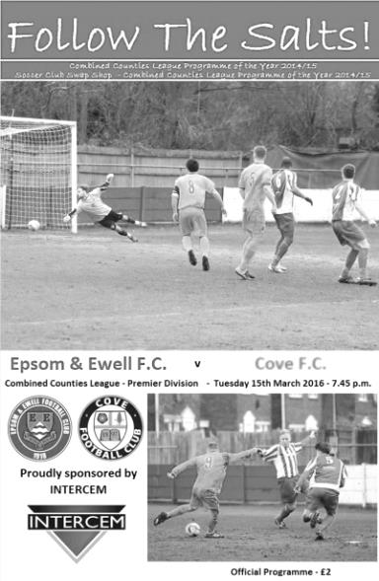
Last gasp Farrell header breaks the Cove resistance

Matt Farrell's fourteenth goal for our club may prove to be extremely important, as it clinched three points and enabled us to keep pace with the leaders. However, it could also turn out to be fairly insignificant as we struggled to break down a resolute defence over 90 minutes and without improvement this will surely come back to bite us in matches to come.

Make no mistake here, there was only one team in this match as Cove failed to register a shot on target or even claim a corner. Michael Eacott had one catch from a right wing cross to deal with and almost the whole of the match was played in the segment of the field between the half way line and the edge of the visitors’ penalty area, but they defended superbly throughout, covering every inch and denying our players the opportunity to threaten very often.

It's on days like this that you realise how important a creative midfielder can be. Without the mercurial Matt Ferdinando, who was suspended, we lacked the ability to get behind either full back and were totally unable to find our leading scorer Kyle Hough, who I cannot recall having a shot at goal. Apart from Ferdinando we had a full strength team to choose from and even club Captain Sam Currie made a start; his first since our 3-3 draw at Hartley Wintney. We went back to a more regular formation after our brief experiment with a 3-5-2 against Knaphill but Cove packed the midfield themselves, and whilst this meant that they sacrificed their attacking threat for almost all of the game, it did allow them to stifle and frustrate our players throughout the match.

It has to be said that the only player who could emerge from the first half with any credit was Elliott Thompson who was involved with a lot of the play. However, over the opening 45 minutes there was not a single shot on target for either side. Tom Neale stretched to volley a dropping ball but put his effort wide just before the half hour, while Savvas 'Agi' Panayiotou was a couple of feet over the bar with a shot from 25 yards after his original free kick had rebounded back to him off the defensive wall. Reisse Griffin also had a try with a free kick which was just wide of the far post from 25 yards but this was the sum total of our threat, with corners failing to clear the first man

or crosses from either flank doing likewise.

You felt that things would pick up in the second half, and they did, slightly! Neale made a good run down the right hand channel but was unable to square the ball into the danger area and he again came close after Farrell's poor corner somehow found its way into the danger area; the ball looped up off a defender but his overhead kick was over the bar by a yard or two.

On the hour Neale and Panayiotou were replaced by Rob Hendry and Bentley Graham and within seconds Farrell had set Hendry up and from 12 yards he went for the far post from an angle but screwed his shot beyond it. We continued to press but were beginning to lose patience a little as the thought that we would be handing Cove their first away point of the season began to loom on the horizon. That thought came fully into view after 81 minutes when Graham's low square pass found Farrell inside the six yard box but somehow his shot hit the bar and rebounded away to safety.

As the game limped into injury time discussions were being held as to whether Cove deserved a point for defending so well throughout the game when in the ninety-first minute a left footed cross from Hendry out on the right wing was met by the skinniest of headers from Farrell six yards out and the ball crept past Jake Maddox into the far corner. It was a strange feeling as there was little in the way of cheering from where I was; more a mixture of surprise and relief that we had broken through what was looking like an impregnable wall right at the death. It nearly became two-nil right at the end of four minutes injury time when Graham cut in from the left and struck at goal. Maddox blocked the ball well but then lost it and only a despairing lunge with the keeper's foot was able to deny Farrell once again as he tried to round the keeper. Maybe he should have hit it first time, being only three yards out but this was soon forgotten as the final whistle blew shortly after and we had won, just!

After witnessing the entire ninety minutes of football two things were very clear to me. 1) Cove will go down this season. They, like Redhill before them in February when they visited, played competitively and with much effort, but they are so far adrift from the rest that without a cutting edge up front they will not win enough of the games that they need to survive. I back them to surprise one of the top clubs before the end of the season though. 2) If we don't improve shortly, then all the hard work and great performances so far this season will count for little and you could tell that our Management team were frustrated with what they were seeing. Yes, the pitch was a bit hard and bumpy, but it's the same for both teams and we have to find a way through if other teams decide to come here and play for a point in a similar way, or next time I may be reporting on how they managed to succeed in that task.

It would be a frustrating end to the season if that were to happen, but maybe this was a wakeup call that we will hear and on Saturday at Chessington & Hook, weather permitting, we will see a much better performance in the final third of the field.

Team: Michael Eacott, Sam Currie (c), Matt Tanton, James Taylor, Craig Hastings, Elliott Thompson, Savvas 'Agi' Panayiotou, Matt Farrell, Kyle Hough, Tom Neale, Reisse Griffin

Subs: Rob Hendry for Neale (60), Bentley Graham for Panayiotou (60)

From behind the goal
Farnham Town 1-2 Epsom & Ewell
Combined Counties League – Premier Division - Tuesday 22nd March 2016

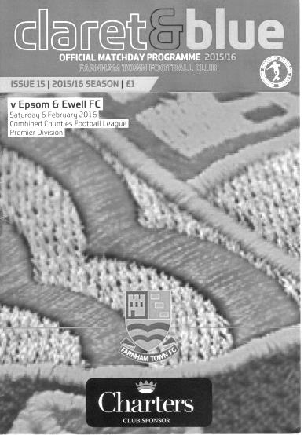
Graham's last minute brilliance secures the points in game of few chances

If somebody had told me at half time that this match would produce three goals, two of the highest quality, and a really exciting ending, I would have laughed! Of course, strange things happen in football, and as it turned out, our second late winner in two matches kept us involved in the promotion hunt.

In terms of personnel, Dan Dean came in at the back while Bentley Graham also started again, and his last minute goal secured all three points, after it looked as though we would have to settle for just one. Despite reverting to the 3-5-2 formation that we saw briefly against Knaphill ten days previously, the game resembled our more recent outing against Cove, with our boys holding the bulk of the possession but rarely looking like breaking through.

In fact, there was nothing of note in the opening twenty minutes to report upon, except to say that we held the balance of possession. Tom Neale struck an effort wide from the edge of the box after beating a couple of men, but on a tricky surface defences were always likely to hold the upper hand and chances were at a premium.

The visitors hit a long range effort wide just before the half hour and in the 34th minute they won a corner. This was notable as it was the first one we had conceded in over two hours of football! Most of the game was at the other end of the park though and just before half time Reisse Griffin put in a dangerous low ball that whizzed across the six yard area just in front of Kyle Hough and away for a throw in on the other side. With almost the final action of the half, a Matt Tanton cross was just punched away from the incoming Craig Hastings by the impressive Richard Ossai; one of an elite group of keepers who have actually denied Kyle Hough from the spot!

The second half continued in a similar vein, although the home side came close with a twenty yard shot from Luke Whiddett that Michael Eacott did really well to turn over the bar, especially considering his lack of involvement in the game to that point. After that, we pushed again although had a scare when Tanton went in fractionally late on a home player. It looked quite serious for a while and it was a relief to see just the yellow card brandished. Graham then tried his luck from 25 yards but the flying Ossai made a similar one-handed save to Eacott's one earlier to concede a corner.

As we reached the 78th minute the game took the first of its turns when their striker went down under a challenge from Dan Dean, right on the corner of the penalty area. Whether it was inside or not was irrelevant as the referee decided that it wasn't a foul anyway, and on the break Hough was put through on the left; his shot deflected off a defender and looped up over the keeper where Neale was lurking at the back post to drive the ball into the net from close range for the opening goal.

The penalty "non-decision" annoyed some of the home players, one of which, Darren Wilson received a yellow card for his protestations. We nearly made it 2-0 as a great Currie pass reached Graham who got a touch to the ball ahead of the keeper but in doing so, took it wide and was unable to make the chance count. However, Farnham were trying their hardest to get back in the game and I began to wonder whether we should revert to a more defensive four at the back for the closing stages.

In the 86th minute we were made to pay. Craig Hastings was deceived by a bobble on the pitch and lost possession, agriculturally hacking down his opponent on the edge of the area. Again, another official might have decided that the offence was worth a red card, having been deliberate, but maybe we were due a bit of luck on the disciplinary front for a change and just the yellow card was given. However, our luck was right out from the resultant free kick as the shot came in and wasn't dealt with. A little panic ensued, although just as it appeared we had cleared the danger outside the penalty area, the ball was smashed back into the top corner of the net by Whiddett for a superb equaliser in the 87th minute. A cleaner volley you could not expect to see at any level and needless to say, Joe Hart wouldn't have saved it, let alone the unlucky Eacott who could only admire it as it flew by him at speed.

Having finally got ahead after all that hard work, the late equaliser was a tough blow for our boys to take, but despite time running out we managed to create one more opportunity. We passed the ball around on the edge of the area, trying to find a way through the massed ranks of Farnham defenders, but then Graham broke through on the left hand side of the area, cut back inside one defender and then another before stroking the ball under Ossai from close range. I was willing him to shoot earlier, fully expecting a tackle to come in, but the skill displayed on that surface was superb and although it wasn't quite Ricky Villa in the 1981 F.A. Cup Final (for our older readers), it wasn't far short of it.

Two late winners in recent matches have ensured that our season is still alive and well and on balance we did deserve the win, having held the ball for far longer than the home side. Maybe next time we could avoid leaving it so late chaps, as I'm not sure I can handle too many more photo finishes!

Team: Michael Eacott, James Taylor, Matt Tanton, Dan Dean, Craig Hastings,
Sam Currie (c), Reisse Griffin, Matt Farrell, Kyle Hough, Bentley Graham, Tom Neale

Subs: Elliott Thompson for Tanton (70), George Murphy for Dean (78),
Savvas 'Agi' Panayiotou for Currie (92)

Club Records - 25th March
Date | Day | Competition |  | Opponents |  | Scorers
25/03/32 | Fri | London League | A | Tooting Town | 5-1 | B.Williams (4), L.Graves
25/03/33 | Sat | London League | A | Cray Wanderers | 1-4 | R.Marlow
25/03/39 | Sat | London League | H | P.O.Engineers | 3-2 | T.Rochester, B.Solly, A.Curtis
25/03/50 | Sat | Corinthian League | A | Walton & Hersham | 0-5
25/03/61 | Sat | Corinthian League | H | Wembley | 1-1 | G.King
25/03/72 | Sat | Athenian League 2 | H | Ruislip Manor | 0-3
25/03/78 | Sat | Isthmian League 2 | H | Egham Town | 1-0 | J.Hunn (pen)
25/03/89 | Sat | Isthmian League 2s | H | Ruislip Manor | 0-1
25/03/93 | Thurs | Southern Combination  Cup 2 | H | Walton & Hersham | 3-2+ | P.Meredith, T.Tweedy, A.Nimmo
25/03/95 | Sat | Isthmian League 3 | A | Leighton Town | 1-0 | K.Webb
25/03/00 | Sat | Isthmian League 3 | H | Camberley Town | 2-1 | B.Forey, D.Marvell
25/03/06 | Sat | Isthmian League 2 | H | Chalfont St Peter | 0-4
Historical Decades
Date | Day | Competition |  | Opponents |  | Scorers
90 years ago – Epsom Town F.C.
27/03/26 | Sat | Surrey Senior League | H | Egham | 3-0 | R.Sperring, W.Challis, R.Marlow
80 years ago – Epsom F.C.
28/03/36 | Sat | London League | A | Dagenham Town | 0-1
70 years ago – Epsom F.C.
23/03/46 | Sat | London League | H | Carshalton Athletic | 2-3 | K.Holliday, K.Minter
60 years ago – Epsom F.C.
24/03/56 | Sat | Corinthian League | H | Tilbury | 3-0 | J.Sorensen, N.Ambrose, D.Hermitage
50 years ago – Epsom & Ewell F.C.
26/03/66 | Sat | Athenian League 2 | A | Eastbourne United | 1-3 | T.Wiltshire
40 years ago – Epsom & Ewell F.C.
27/03/76 | Sat | Athenian League 2 | A | Feltham | 0-0
30 years ago – Epsom & Ewell F.C.
27/03/86 | Thur | Isthmian League  Premier Division | H | Hitchin Town | 3-3 | R.Lewis, T.Tuite, R.Kidd (pen)
20 years ago – Epsom & Ewell F.C.
26/03/96 | Tue | Isthmian League 3 | A | Flackwell Heath | 2-1 | P.Meredith, S.Miller
10 years ago – Epsom & Ewell F.C.
25/03/06 | Sat | Isthmian League 2 | H | Chalfont St Peter | 0-4

History Corner - 25th March
90 years ago this week we were closing in on our first ever Surrey Senior League title and this was our fifth home league win in a row. This was particularly good news as following this 3-0 defeat of Egham, we had six matches remaining, all of which would be played at our new West Street ground and yes, we won the lot to confirm the title, but more of that in a later issue. Reg Sperring, Wilfred “Bronk” Challis and Reg Marlow all found the net in a match where we were slightly flattered by the score line. The following week we would score ten goals as we defeated Guildford by ten goals to three. Guildford would finish fourth in the table and we had just recently drawn there. It was an exciting time to be a supporter!

84 years ago today Billy Williams scored four times in our Good Friday match at Tooting Town. Tooting were one half of the forerunners of Tooting & Mitcham United and were already resident at Sandy Lane. Their “partners” Mitcham Wanderers were also regular league and cup opponents but they moved out of Streatham Road in 1932 to merge into the club we know today.

Williams himself was originally a young professional at West Ham United and in his time at our club would score at a phenomenal rate, registering at a rate of over one and a half goals in every match, finishing with 73 goals in just 48 appearances! This is the greatest strike rate of any regular Epsom player in history and his record will surely never be broken. Tommy Tuite our leading scorer reached a mark of 391 but if Williams had played the same number of games, scoring at his incredible rate, he would have had 885!!

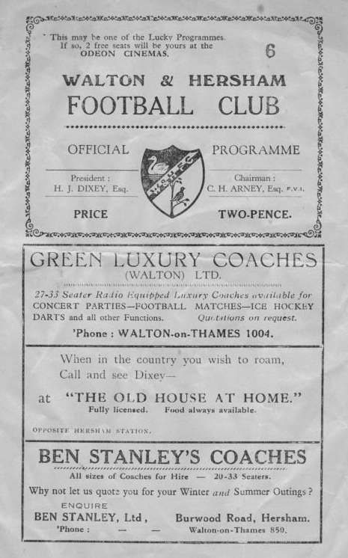
56 years ago today we were thrashed 5-0 at Walton & Hersham’s Stompond Lane ground. The main story was the inclusion in the Epsom side of a young defender by the name of F.Reid who was only 15 years old! He was a member of the Fulham Ground staff and played at left back in this game, but from looking at Fulham records it does not appear that he made the leap into their first eleven. He never played for us again either! (see programme right)

38 years ago today a Jeff Hunn penalty would seal a 1-0 home win against Egham Town, who were no connection to the team I wrote about higher up on the page, having been formed as recently as 1963. Manager Pat O’Connell had arranged for the players to have a pre-match lunch at the White Horse Hotel which was near the Amato pub around the back of Epsom, so we were certainly well-prepared for the match! This win was important because it kept us at the top of the inaugural Isthmian League Division Two table and by the time we visited Tempest Road for the return leg exactly one month to the day later, our 3-1 win there was irrelevant as we had already been crowned Champions by then!

27 years ago today we continued our poor run of home form against Ruislip Manor when they scored the only goal with a long range strike. Making his debut this day as a substitute for Player/Manager Ricky Kidd was a 17 year old Nigel Bennett who would eventually clock up 630 appearances for the club, the second highest mark in history. What is not known about Nigel is that he also chalked up a number of youth and reserve team appearances too, making him the person who donned the blue shirt more than anyone else!

Looking Up
Ryman League Division One South Table
incl Tuesday 22nd March | P | W | D | L | F | A | Pts | GD
Folkestone Invicta | 40 | 30 | 6 | 4 | 82 | 29 | 96 | +53
Dorking Wanderers | 40 | 24 | 8 | 8 | 87 | 45 | 80 | +42
Worthing | 39 | 23 | 5 | 11 | 82 | 48 | 74 | +34
Faversham Town | 40 | 22 | 7 | 11 | 59 | 40 | 73 | +19
Hythe Town | 40 | 22 | 6 | 12 | 59 | 41 | 72 | +18
Hastings United | 39 | 22 | 4 | 13 | 84 | 54 | 70 | +30
Molesey | 40 | 22 | 4 | 14 | 77 | 68 | 70 | +9
Herne Bay | 39 | 20 | 9 | 10 | 71 | 41 | 69 | +30
Corinthian-Casuals | 40 | 20 | 7 | 13 | 64 | 50 | 67 | +14
Ramsgate | 39 | 19 | 7 | 13 | 78 | 61 | 64 | +17
Carshalton Athletic | 40 | 19 | 7 | 14 | 71 | 65 | 64 | +6
South Park | 39 | 19 | 7 | 13 | 66 | 60 | 64 | +6
Guernsey | 40 | 19 | 4 | 17 | 84 | 76 | 61 | +8
Three Bridges | 39 | 18 | 4 | 17 | 49 | 55 | 58 | -6
Whyteleafe | 40 | 17 | 5 | 18 | 59 | 63 | 56 | -4
Tooting & Mitcham United | 40 | 15 | 7 | 18 | 56 | 58 | 52 | -2
Walton Casuals | 39 | 14 | 6 | 19 | 61 | 69 | 48 | -8
Sittingbourne | 40 | 15 | 3 | 22 | 56 | 67 | 48 | -11
Chatham Town | 40 | 12 | 6 | 22 | 52 | 58 | 42 | -6
Chipstead | 40 | 9 | 5 | 26 | 49 | 83 | 32 | -34
East Grinstead Town | 39 | 8 | 6 | 25 | 43 | 76 | 30 | -33
Walton & Hersham | 40 | 9 | 5 | 26 | 46 | 92 | 29 | -46
Peacehaven & Telscombe | 40 | 6 | 6 | 28 | 43 | 109 | 24 | -66
Whitstable Town | 40 | 4 | 2 | 34 | 41 | 111 | 14 | -70
The first item of particular relevance to us as Epsom and Ewell supporters is the resurgence and likely survival of Chipstead. They looked dead and buried at one point and as they dispensed with our former Manager Lyndon Buckwell and moved to their third Manager of the season, I feared that they were clutching at straws. Fair play to them as they now sit three points clear of the final relegation spot, although current projections from those who are knowledgeable in these matters show that all three teams will currently go down, so they need to keep working.

At the top, Folkestone Invicta are set to return to the Premier Division once again, requiring just one more win to confirm the title. Below them, Dorking Wanderers look set for a play off spot, assuming that their Westhumble ground is considered good enough to host Step Three football, which personally, I doubt. Worthing, Faversham Town and Hythe Town are currently holding the other play off positions, but Hastings United, Herne Bay and interestingly, Molesey are just outside those spots and any one of them could still sneak in.

I wrote earlier in the season that I thought South Park and Guernsey would be close to the play offs but this hasn’t materialised and both are set for midtable finishes, although at the bottom, Whitstable Town and Peacehaven & Telscombe are surely doomed. For Whitstable, a return to the Southern Counties East League will eliminate any remote thoughts of ourselves being transferred Eastwards, while for Peacehaven it will be their second straight relegation.

Looking Up
Evo-Stik Southern League Central Division Table
incl Tuesday 22nd March | P | W | D | L | F | A | Pts | GD
Kings Langley | 35 | 22 | 4 | 9 | 71 | 41 | 70 | +30
Royston Town | 34 | 21 | 6 | 7 | 83 | 37 | 69 | +46
Egham Town | 35 | 22 | 3 | 10 | 66 | 32 | 69 | +34
St Ives Town | 35 | 19 | 10 | 6 | 58 | 29 | 67 | +29
AFC Rushden & Diamonds | 35 | 19 | 7 | 9 | 72 | 40 | 64 | +32
Aylesbury | 33 | 18 | 6 | 9 | 59 | 37 | 60 | +22
Chalfont St Peter | 36 | 19 | 2 | 15 | 64 | 62 | 59 | +2
Northwood | 34 | 17 | 7 | 10 | 51 | 40 | 58 | +11
Beaconsfield SYCOB | 36 | 16 | 8 | 12 | 64 | 47 | 56 | +17
Ware | 36 | 16 | 6 | 14 | 60 | 62 | 54 | -2
Godalming Town | 34 | 15 | 8 | 11 | 41 | 36 | 53 | +5
Potters Bar Town | 35 | 14 | 9 | 12 | 54 | 53 | 51 | +1
Petersfield Town | 32 | 13 | 5 | 14 | 59 | 61 | 44 | -2
Bedford Town | 36 | 11 | 9 | 16 | 50 | 55 | 42 | -5
Fleet Town | 35 | 12 | 5 | 18 | 51 | 70 | 41 | -19
Uxbridge | 35 | 11 | 7 | 17 | 52 | 62 | 40 | -10
Barton Rovers | 33 | 8 | 12 | 13 | 41 | 54 | 36 | -13
Arlesey Town | 36 | 10 | 5 | 21 | 38 | 79 | 35 | -41
Hanwell Town | 34 | 8 | 8 | 18 | 36 | 55 | 32 | -19
Aylesbury United | 34 | 7 | 6 | 21 | 34 | 71 | 27 | -37
Leighton Town | 35 | 6 | 7 | 22 | 35 | 74 | 25 | -39
North Greenford United | 36 | 5 | 6 | 25 | 44 | 86 | 21 | -42
Taking up the running in the Southern League Central Division are last season’s South Midlands League Champions, Kings Langley. I went there on the August Bank Holiday to see them completely outplayed by Northwood, yet win 2-0, so clearly they have grown in confidence since then and head the league at this point, but it’s very tight at the top this season.

Royston Town sit one point behind with a game in hand. I also saw them play this season in a 1-0 win at Hanwell Town in January and they did look a very solid outfit indeed. Behind them are Egham Town and whilst I have no great love for this team, as they have regularly opposed us in the past, their current Manager is one Gary Meakin, former Epsom and Ewell player in the late nineties. His father Graham was our Captain a few years previously. He is still very young in Managerial terms yet has had time at Beaconsfield and at Wingate & Finchley. They are still very much involved as are the other team I suggested to look out for which was AFC Rushden & Diamonds. Behind them Aylesbury FC are also in with a shot if they can win their games in hand.

At the wrong end of the table are North Greenford United and Leighton Town. Only two can go down here and of the others I think only Aylesbury United (now ground sharing at Thame United while their old ground rots) could also get involved here. Would North Greenford United come down to our League again? A few years ago they were members of the Combined Counties League but that was in the days when Wembley FC was here too. Since the Lions now play in the South Midlands League I believe this will be their fate too, which is good news for Chessington & Hook United who may even avoid relegation as a result.

Looking Down
Combined Counties League Division One Table
incl Tuesday 22nd March | P | W | D | L | F | A | Pts | GD
CB Hounslow United | 26 | 19 | 4 | 3 | 59 | 22 | 61 | +37
Abbey Rangers | 27 | 18 | 3 | 6 | 62 | 29 | 57 | +33
Bedfont & Feltham | 25 | 17 | 2 | 6 | 64 | 35 | 53 | +29
Worcester Park | 24 | 16 | 4 | 4 | 62 | 23 | 52 | +39
Eversley & California | 23 | 16 | 1 | 6 | 67 | 33 | 49 | +34
Banstead Athletic | 21 | 12 | 4 | 5 | 54 | 34 | 40 | +20
Dorking | 24 | 12 | 1 | 11 | 44 | 38 | 37 | +6
Cobham | 28 | 11 | 3 | 14 | 49 | 59 | 36 | -10
Ash United | 27 | 9 | 7 | 11 | 46 | 52 | 34 | -6
Frimley Green | 25 | 10 | 3 | 12 | 39 | 40 | 33 | -1
Staines Lammas | 27 | 10 | 3 | 14 | 48 | 51 | 33 | -3
Sandhurst Town | 25 | 7 | 5 | 13 | 41 | 73 | 26 | -32
Sheerwater | 26 | 6 | 3 | 17 | 40 | 60 | 21 | -20
Dorking Wanderers Reserves | 22 | 5 | 5 | 12 | 26 | 45 | 20 | -19
Farleigh Rovers | 23 | 5 | 1 | 17 | 22 | 66 | 16 | -44
Epsom Athletic | 19 | 4 | 2 | 13 | 28 | 55 | 14 | -27
South Park Reserves | 22 | 3 | 3 | 16 | 28 | 64 | 12 | -36
In view of the late run made by Chessington & Hook United last season it is impossible to completely ignore Banstead Athletic’s fine run of form, but I believe that the top three will come from the clubs currently occupying the top five positions.

CB Hounslow United have been heading the table for much of the season, while Eversley & California have fallen away somewhat in recent weeks. This may be connected with the rumour I heard that stated they were not looking to go up, despite now having the floodlights in place that were the cause of their failure to be accepted to the Premier Division a couple of seasons back.

I asked the question a few months ago when referring to Bedfont & Feltham about whether it is better to have points in the bank or games in hand. The answer to this is dependent on how many games in hand and how many points you need to make up, but the junior club at Hatton Road may well be coming up to join their next door neighbours once again. It is a good news story as both halves of this club used to grace the Premier Division of this league and in Feltham’s case, were higher still and as an Isthmian League club, played us a few times in the late seventies and then throughout the eighties on the infamous artificial surface at the Feltham Arena.

Worcester Park of course cannot go up, but relegation appears more remote as the F.A. agreed a further stay of execution until 2018, although they can still be relegated if the League reaches its full complement of 20 clubs. We will definitely see a few new clubs at this level next season.

The final club of the “big five” is Abbey Rangers and as a new club this season I am not yet sure whether their ground is ready for a second promotion. I’m hearing that they may have to wait another season before they get their chance, but could be wrong.

At the bottom there will be no relegation but South Park Reserves looked quite good last Saturday when I watched their 4-1 win at Sheerwater and I believe will be stronger still next term. I also believe that Dorking Wanderers Reserves have resigned and believe this is likely to have something to do with their offer of hosting Dorking’s matches at Westhumble next season.

Our friends Hoddesdon Town
Spartan South Midlands League - Current Table 2015/16
incl Tuesday 22nd March | P | W | D | L | F | A | Pts | GD
Hoddesdon Town | 34 | 25 | 4 | 5 | 71 | 24 | 79 | +47
AFC Dunstable | 32 | 23 | 5 | 4 | 87 | 28 | 74 | +59
London Colney | 31 | 22 | 6 | 3 | 73 | 23 | 72 | +50
Hertford Town | 33 | 17 | 8 | 8 | 95 | 61 | 59 | +34
Berkhamsted | 31 | 16 | 6 | 9 | 73 | 46 | 54 | +27
Tring Athletic | 32 | 15 | 8 | 9 | 51 | 35 | 53 | +16
Holmer Green | 30 | 17 | 2 | 11 | 64 | 61 | 53 | +3
Biggleswade United | 33 | 15 | 6 | 12 | 46 | 41 | 51 | +5
Hadley | 26 | 16 | 2 | 8 | 59 | 34 | 50 | +25
Wembley | 35 | 15 | 5 | 15 | 60 | 51 | 50 | +9
Welwyn Garden City | 30 | 14 | 7 | 9 | 64 | 38 | 49 | +26
Cockfosters | 33 | 12 | 12 | 9 | 62 | 49 | 48 | +13
Sun Sports | 34 | 13 | 6 | 15 | 61 | 65 | 45 | -4
Stotfold | 31 | 10 | 7 | 14 | 54 | 66 | 37 | -12
London Tigers | 30 | 10 | 7 | 13 | 44 | 60 | 37 | -16
FC Broxbourne Borough | 31 | 10 | 5 | 16 | 45 | 74 | 35 | -29
Leverstock Green | 32 | 8 | 7 | 17 | 64 | 75 | 31 | -11
St Margaretsbury | 34 | 6 | 7 | 21 | 45 | 83 | 25 | -38
Colney Heath | 33 | 7 | 3 | 23 | 28 | 71 | 24 | -43
Oxhey Jets | 32 | 8 | 0 | 24 | 42 | 105 | 24 | -63
Harefield United | 34 | 6 | 4 | 24 | 30 | 83 | 22 | -53
Bedford | 33 | 6 | 5 | 22 | 39 | 84 | 20* | -45
* Bedford – three points deducted
Well, would you look at that!

When we played Hoddesdon Town in a friendly in August, defeating them 5-1 on an admittedly poor surface, we thought they were a half decent team, but under the new Management of Gavin Kelsey, expected that a midtable season would meet their definition of a successful 2015/16.

Then they went on that incredible F.A. Cup run, defeating Sawbridgeworth, Romford, Ashford Town (Mx) and Sittingbourne before bowing out after a replay to Isthmian Premier League Brentwood Town in the third qualifying round.

This confidence clearly spread to their League form, where they lost their first two matches but now sit at the top of the table and while there are a couple of teams who may well still catch them, their end of season appears likely to be at least as interesting as ours.

It is difficult to compare the standard of the two Step Five leagues, but none of their clubs had success in the F.A. Vase this year while we had four clubs in the last 32. A recent guide might be provided by Wembley FC, still prompted by the 106 year old Ian Bates in midfield! They sit in midtable which is slightly higher than the positions they were occupying in our leagues.

Former clubs in this league that we have met, including Wembley of course, are Hertford Town, Berkhamsted and Harefield United, although Tring Athletic’s ground at the Pendley Sports Centre in Cow Lane is one we visited many times to play an earlier club on that site, Tring Town. Incidentally it is nearly twenty years since that 11-1 win over Tring but more on that in the next programme!

There’s no place like Home – Or is there?
Here’s one for the people out there who like statistics. Ok, just me then!

It has often been mentioned in recent years that we don’t do very well at home and our away record must be considerably better. So I thought I would look into this in a bit of detail.

Are we better at home than we are away? The answer is a resounding Yes!......... And No!!


To explain that statement, it all comes down to the era we played in. For example, in recent years, and not including this year which is in the balance right now and could go either way, it is most definitely the away record that wins out. For the last five straight seasons, coincidentally since we left Merland Rise, the away record has been better on every occasion, chalking up 54 wins and 17 draws (32 defeats) over that five year span, compared to just 42 wins and 15 draws (46 defeats) from our home matches. Ouch! To see we have lost more matches at home that we have won is a real shock, when considering how good our league positions have been in recent years.

However, for thirty of our first 31 senior seasons, our home record won out, with only one exception, in 1929/30 when the away record just edged it. For the 49 years in between, it is a more even record of 30 home and 19 away.

Overall, the balance is 60 home and 25 away so it is definitely the best place to play, but could it be that the order is changing? I have a theory. Travel!

Back in the old days, home advantage was clearly greater. The away trips were much longer, all day events in those pre-M25 days. If you were going to play in Essex you would have to head up the A24 to London, head over London Bridge and then take a right turn. Speeds were much slower and players could often be unreliable when faced with a longer trip, that let’s face it, they weren’t getting paid for! Many had to work on a Saturday morning or could not get the time off to travel midweek either.

As conditions improved on the roads, so did the away records. Nowadays, our League has the smallest footprint of any Senior status League in the Country and some clubs, right in the middle of our catchment area like say, a Chertsey Town, hardly ever need to journey much further than 20 miles in any direction. Since we have been in this League, we have had a better away record in six of the nine completed years so far, and a good finish away from home, which contains - on paper - an easier schedule than our home run-in, would see that five year sequence I referred to earlier extended for a sixth straight season.

Some may ask whether the lack of a permanent ground has had an effect, but the argument doesn’t really stand up to analysis. To take a twelve year span either side of leaving West Street, we had a better home record on eight occasions in that spell at our old ground compared to a very similar seven seasons at Merland Rise.

Anyway, here is a seasonal summary of our history. Plenty of light reading for you all!

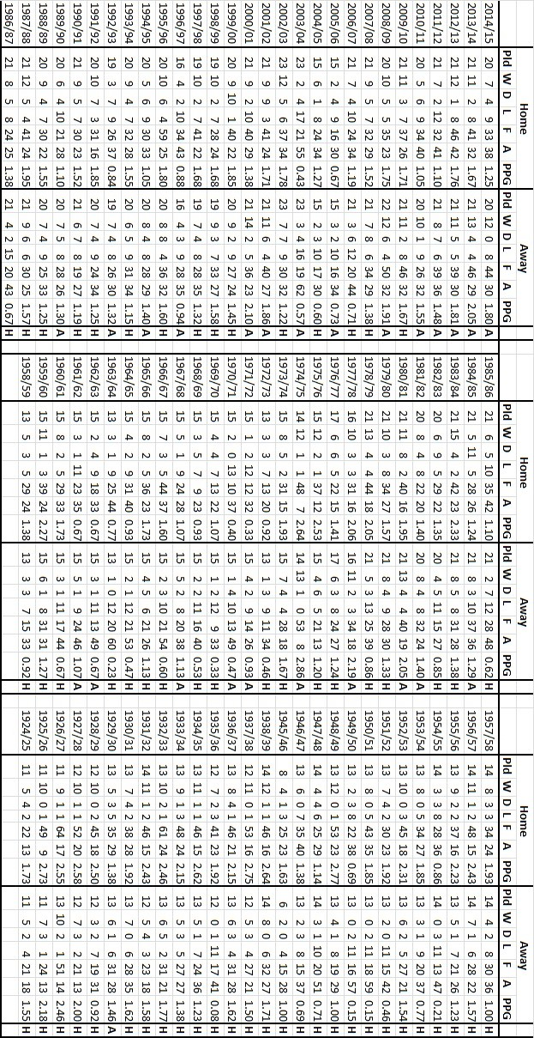

Matches against Westfield
We have met Westfield on 17 previous occasions, dating back to 1964 and while some of the matches have carried a fair degree of importance, some were of less interest!

Our first meeting was an early first qualifying round tie in the Amateur Cup at Old Woking Park; a ground that they first began to inhabit in the early sixties. In 1963 they had joined the Surrey Senior League so by the time of this opening meeting on 10th October 1964 they were approximately two levels below us as we sat in the middle division of the Athenian League at the time. Our regular hotshot of the day was Bill Mackay and he scored a second half winner as we progressed to the third qualifying round. However, we weren’t very good ourselves and were then knocked at out by BAC Weybridge, another Surrey Senior League team a couple of rounds later.

If that was bad, the next meeting just three weeks later was downright disastrous. Despite having won so recently at Woking Park, we were then battered 5-1 in a Surrey Senior Cup tie at the same venue, trailing 2-1 at the half and falling apart completely in the second. It won’t come to any surprise to anybody that we were relegated at the end of that season!

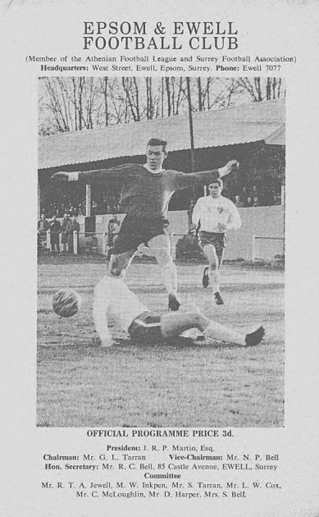
Our next meeting came almost three years later on Saturday 21st October 1967 and again in the Amateur Cup. (see programme left) This time the match was played at West Street and although our team wasn’t any better that season, we did record a 6-1 win; our largest to date in the sequence of matches between the clubs. Roy Battams scored twice as did Ted Stafford with the other two goals coming from long serving players John McNaught and Graham Hemphrey. We even had a young Chris Kelly in our line-up that day! In fact home results have stood up well for us as we have won on each of the nine previous occasions we have met at any of our home venues. Fingers crossed for today!

In 1973/74 matches began to take on a little more in the way of significance. We had just been rejected by the Athenian League and had been accepted into the Surrey Senior League at short notice. At this point, the big team were Westfield who had won the League and Cup double in 1972/73 and were clearly the team to beat.

Not that many of the Epsom supporters would have been thinking along those lines after a decade of almost constant struggle on the field. It looked like a natural level that we would settle into and remain at over the next few years. Our new Manager Pat O’Connell had other ideas of course, and set about rebuilding the team by only retaining a handful of the previous season’s players, most notably Alan Webb. Many new faces appeared and of course the best known of these to supporters today was our young striker Tommy Tuite.

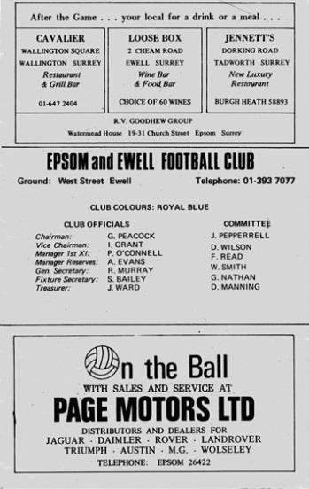
These were exciting times and a measure of what could be achieved was realised on 17th November 1973 when Westfield visited West Street and were beaten 2-1. Goals came from Dave Ritman and Kelvin Gregory to hand Westfield and their Manager John Martin what would prove to be their only League defeat of the season. (see programme left)

In addition to the league matches, we were paired together in the League Charity Cup. Back then the League used to run two knockout competitions and the Charity Cup was the older of the two, having been won by Epsom Town back in 1927. We went there on Saturday 5th January 1974 and although we trailed at half time Tuite enabled us to force extra time and the match finished 2-2 thanks to another goal from Captain Trevor Wales. In the replay at West Street two weeks later goals from Tuite and another player who survived the O’Connell “cull” Marc Talmage ensured passage by way of two goals to one.

Our final meeting of the season came right at the end of it, on a Tuesday evening, 14th May 1974 when Tuite scored again to rescue a point in a 1-1 draw after we had trailed at the half. Westfield were Champions and we had finished second, but matters happening at Wimbledon of all places would have a massive effect on matters at Old Woking Park for 1974/75.

The Dons had a new Manager, Allen Batsford. He was the man who had achieved so much at Walton & Hersham, including the winning of the Amateur Cup in 1973 without even conceding a goal! Famous names like Roger Connell, Richard Teale, Keiron Somers, Colin Woffinden and some chap by the name of Dave Bassett were all part of the furniture and when Batsford took on his new job, these players and others came with him. This left Walton & Hersham in a bit of a mess and John Martin got a call. Although he didn’t go immediately, Westfield would be hit badly by the whole matter and from being Champions in 1972/73 and 1973/74 they would finish bottom of the league in 1974/75.

Of course this made no difference to our players who were in a different class to the rest in the Surrey Senior League that season and would win it with an incredible record of W23 D2 L1! We defeated them home and away at the end of the season, winning 3-1

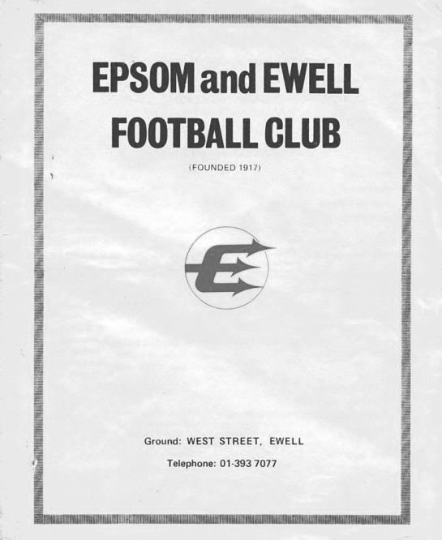
there on 26th April 1975 and 4-1 in the return at West Street on 15th May 1975. We had met earlier in the season, back on 12th October 1974, again in the Charity Cup, defeating them 6-2 at West Street on our way to the Final. (see programme right)

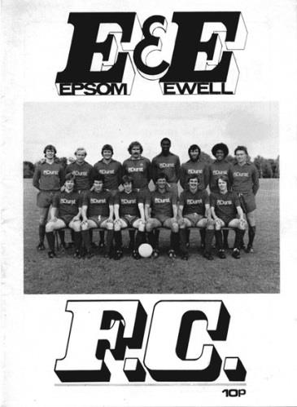
As you might expect, meetings became infrequent as we worked our way up the pyramid, although we did host them at West Street on 13th December 1980, requiring a late own goal to enable us to progress through this fourth qualifying round Surrey Senior Cup tie by two goals to one. This was hugely significant as we won the trophy for the only time in our history later in the season and it’s easy to forget that it could so easily have gone pear shaped right back in the opening round! (see programme below)
Our next meeting did not come for twenty two years and it was a hugely underwhelming one when it did, even though it was in the very same competition that our last one had been.

We won the match 4-2 at Merland Rise on 17th September 2002 but what is the most surprising feature of this match, especially considering that we were playing in the Isthmian League Division One South at the time, was that it was witnessed by the lowest crowd in our first team history, just 16!!

The story comes more up to date now as we didn’t meet again until we were in the Combined Counties League. We should maybe have met in 2006/07 following our transfer from the Isthmian League but they were one of a number of clubs demoted due to ground grading issues as the F.A. tried to find a way to

accommodate the half a dozen clubs being moved over once the Isthmian League had closed their Second Division. Arguably we were fortunate not to find ourselves playing at Step Six, as we had finished second from bottom in that final Isthmian season but we survived and indeed had to wait until the 2013/14 season before their promotion finally enabled them to return to the top flight.

By this time of course the Woking Park ground had been completely recreated to allow the new leisure centre to take shape and provide the club with the wonderful facilities they have today. Their first away game of the season was at High Road where two Alex McKay goals gave us an early lead and an injury time consolation for the visitors made no real difference. By the time we visited for the return it was the final match of the season on 3rd May 2014 and we were already confirmed in third place. It was a far more important match for them as they needed the win to displace Cove from the top four and once they had gone ahead with a bit of a long distance fluke they never looked back and defeated us 3-0.

Last season we went there in September, but an early injury to Sean White set us back and we subsided to a 4-0 defeat. We did return the favour on 24th March 2015 with a 3-1 win at High Road; the most notable aspect of that game being a twenty-five yard strike from Sam Robinson that sealed the win after we had lost Matt Ferdinando to a red card. This maintained our perfect home record against them. (see programmes below from that season)

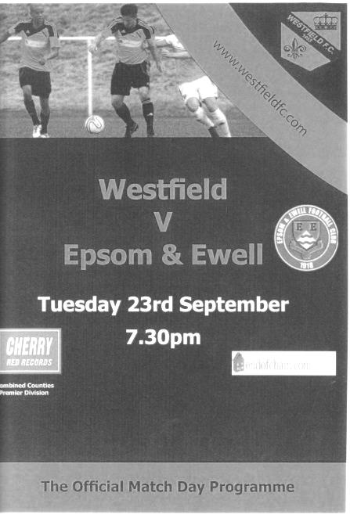
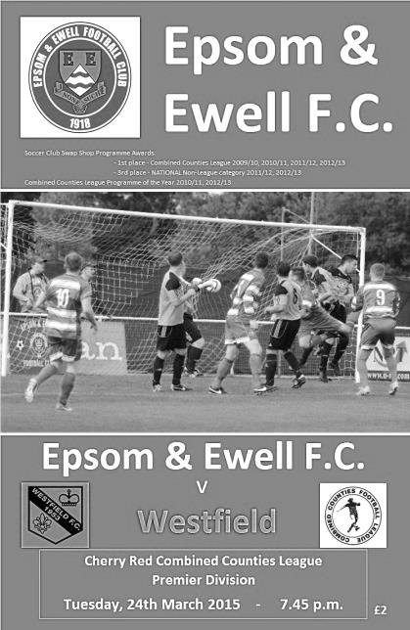

Of course, earlier this season we secured a 0-0 draw over there in a game spoilt by one of the worst officiating performances of the season. Not the worst, obviously, but it was probably second! Hopefully today’s match will be remembered for the football played!

Our most recent meeting!
Westfield 0-0 Epsom & Ewell
Combined Counties League - Saturday 29th August 2015

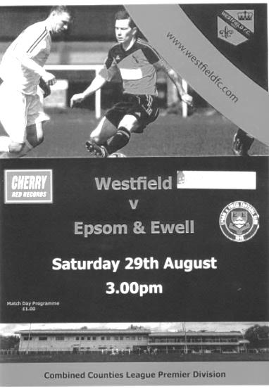
Salts battle injustice to claim a point

Bearing in mind our record at the refurbished Woking Park with two heavy defeats prior to this visit, a point should be seen as a good result. When you throw in the circumstances of the match you could argue with some justification that the first goalless draw under Glyn Mandeville's charge was actually an excellent result.

We made one change from Saturday's win at Sutton Common Rovers with Jakub Kurdziel making his debut at left back for the unavailable Matt Tanton and back on a natural grass surface that was perfect for play after a light shower at the start of the match that continued throughout, both teams started off with good intentions of playing some football. Unfortunately the first half contained little in the way of goal mouth action as the elevens were so evenly matched and committed that they cancelled each other out entirely!

Kyle Hough fired an early chance over the bar from outside the penalty area after Rob Hendry had headed a long Michael Eacott free kick into his path and Matt Farrell volleyed just wide of the far post after Dan Dean had flicked on a Sam Currie header. Apart from these early opportunities the home side shaded possession in the first half but Michael Eacott wasn't required to do anything at all as Dan Dean and Matt Farrell protected our back four excellently all day. Kurdziel had a couple of nervy moments to start with but grew in confidence and did well when a left wing Westfield cross eluded both Eacott and Dale Marvell and our "new boy" was alert to block a strike on goal at the far post just before the half time whistle.

Matt Ferdinando was extremely unfortunate after 37 minutes when his sliding tackle was considered worthy of a yellow card, despite not actually making contact with anyone, but the referee seemed dead set on allowing anything of note to develop, making no use whatsoever of the advantage rule that is actually there to help him, and generally stifling the few opportunities that actually occurred.

The second half started well for us as we started to press a little more. Ferdinando received the ball from a great touch pass by Hough but his run ended with a shot that went well wide. We then had a scare at the other end when a Westfield near post corner was flicked goalwards but Sam Currie was at the far post to clear the danger. It was the first shot on target and it was at this point that you realised that our Captain

had now made one more save at this point than both keepers combined!

But the game was about to take an unsavoury turn as Ferdinando received a second yellow card for a slightly late challenge in the 56th minute. It was hard to see the incident from where I was, but others nearby said that it probably was worth a yellow card. This of course made the harsh decision on his earlier card more of an issue.

A subsequent free kick for the foul looped up towards goal and was cleared by Eacott with the ball close to the crossbar and we struggled to get back into the game for a few minutes as the opposition tried to take advantage of the extra man. Without a doubt the game opened up a bit at this stage, but we replaced the injured Reisse Griffin with Daryl Cooper-Smith, while on the other flank Craig Hastings came on for the injured Jakub Kurdziel and we reshuffled the back line substantially. As a result the last half hour remained very even as we gave as good as we got.

We did have one concern after 73 minutes when Matt Jackson was put through but never really got the ball under control and Eacott was out quickly to smother the danger, picking up a knock in the process that earned the Westfield striker a yellow card.

Because of a lack of confidence in the officiating, notably a yellow card for Farrell for just bumping into a player, followed by a yellow card for the Westfield substitute Andy Wright, who had been on the field for all of twenty five seconds and culminating in a laughably poor decision on a corner kick that was not awarded, the game began to deteriorate. Then Farrell was poleaxed on the edge of the area and we had another talking point.

Despite the wall being just six yards away as was clear from the lines that mark the penalty area, Dale Marvell got his low free kick on target and in the 76th minute Stuart Norman had to make the first actual save of the match, although he was only able to parry the ball and Kyle Hough knocked in the rebound from close range only to then see the Assistant's flag raised for offside somewhat belatedly. People standing across the field and in a better position than me said they believed Hough was onside when the free kick was taken and although we didn't complain about the decision at the time, it really wouldn't have surprised me if this had been the case!

Hastings came forward to meet a deep Marvell corner but his effort was blocked by a defender and as we went further into injury time another Marvell set piece was met at the far post by Cooper-Smith, but the ball had taken a slight deflection on the way and our man was only able to find the side netting with his strike.

But in truth this was a very even game and a goal for us would have been harsh on our hosts in a game of few real chances that will be remembered for a number of bizarre decisions and a flurry of cards from an uncommunicative referee that found himself a bit out of his depth.

Team: Michael Eacott, Sam Currie ©, Jakub Kurdziel, James Taylor, Dale Marvell, Dan Dean, Matt Ferdinando, Matt Farrell, Kyle Hough, Rob Hendry, Reisse Griffin

Subs: Daryl Cooper-Smith for Griffin (65), Craig Hastings for Kurdziel (70), Beckett Oliver for Hendry (87)

Westfield’s last visit
Epsom & Ewell 3-1 Westfield
Combined Counties League - Premier Division - Tuesday 24th March 2015

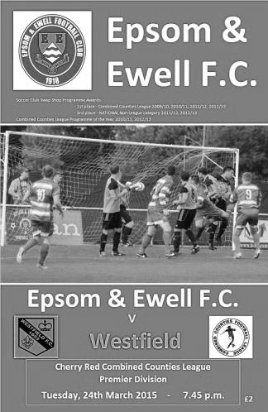
Threadbare Salts have too much quality in the end

There were many similarities with other recent scenarios during the Salts hard earned win over Westfield on Tuesday evening. There were quality goals and a lack of available substitutes, while yet again we finished the game with ten men; our tenth red card of the season. However, one further connection here is that we had won five of those previous nine matches where we finished short and so it proved once more.

Against a team in decent form and wary of our 4-0 defeat at Woking Park in September which was Glyn's first defeat as Manager, I'm sure he would have liked to have named a stronger squad, but with suspensions to Dan Dean and Matt Farrell, added to the absence on holiday of Alex McGregor, of Daryl Cooper-Smith with work, and Ali Dewar with injury, we only named the Manager, our Assistant Matt Smith and a half fit Matt Robinson on the bench. It was still a good starting line-up, we just had to hope that no injuries would befall us.

With our players aware that there were limited options available we started tentatively, not for the first time. Against Badshot Lea a great Michael Eacott save had kept them out in the early part of the match, but this time he was unable to do anything about a smart finish by James Mepham, who had to turn to receive a left foot cross that was played behind him, and with his back to goal, almost back heeled the ball into the far corner of the net. At the very least it was clever improvisation, at best it was a really skilful finish and with 7 minutes on the clock we were behind.

As time went on we started to find our feet and ten minutes after conceding Sam Robinson cut in from the left and ran in along the touch line but his pull back was blocked out at the last moment for a corner that came to nothing. We were beginning to get on top though and our equaliser came after 27 minutes. There was another similarity here if you were at our recent Chertsey match, as a free kick from a fairly innocuous position was delivered expertly onto the head of our striker. At Chertsey it was Steve Rowe to Daryl Cooper-Smith, this time it was Sam Robinson's delivery and Kyle Hough peeling away from his marker to deliver a superb header into the opposite corner, with visiting keeper Stuart Norman doing really well to even get a finger on the ball as it flew into the net.

I'm not sure how many our centre-forward has scored with his head but it's fair to say it isn't many, and five minutes later he was scoring in his more usual manner when a ball forward was sliced by a defender into his path. From the edge of the area, he cut outside the exposed Norman and slotted the ball in between two retreating defenders to put us ahead.

The turnaround was deserved, although there was a concern in between our two goals when Matt Ferdinando went on one of his runs but the ball got away from him and as he tried to reach it, caught the defender and earned a deserved yellow card. This added to another poor challenge just before the break earned him a severe warning from the referee and you felt that if we had any options on the bench, it might have been one of those days where an early substitution would be prudent, but we carried on.

The opposition, clearly annoyed at the way the game had got away from them, raised their game significantly as the half ended and by the time the whistle blew we were maybe fortunate to still be ahead. As we have found out the hard way at times this season, taking chances when you have the opportunity is vital and the visitors had a close range shot that deflected off a defender and over our crossbar, and a right wing cut in after Rowe was dispossessed, although the shot / cross in was too close to Eacott who gathered comfortably.

I am sure that at the break we would have been reminded that we needed to match Westfield in the middle of the park and in the second half we did just that. Captain Sam Currie, together with Ben Hayward who was making his first appearance for a while did a great job and held things together, enabling us to push forward and threaten further goals. Robinson volleyed a loose ball just wide of the post after Hough had been crowded out in front of goal, and although Norman got a touch on it, a goal kick was awarded.

In fact, the second half included a fair number of strange decisions. The first of which came after 54 minutes when Matt Steer went straight through the back of Hough in front of both benches. It was probably because Hough had given him the run around for much of the game, but the challenge was a bad one and having seen the incident, I was really surprised that the referee only gave a yellow card. This decision became even more contentious in the 64th minute when Ferdinando went in for a challenge and was momentarily late on a defender who hit the ground like the proverbial sack of spuds.

Whether the referee was swayed by this or the substantial pressure placed on him by the visitors we will never know, but a second yellow card followed and ended our man's game earlier than he would have liked. There is a school of thought (mine) that says it was a bit harsh, but as was stated to me at the time and by an Assistant after the game, he was already on a yellow card and a final warning so maybe needed to ensure that he didn't provide the referee with the opportunity in the first place. It's hard to argue with that line of thinking.

This was our tenth red card of the season, extending still further our recently set club record, but if there is any sort of a silver lining out of this, it is that our players were more than experienced in dealing with this type of situation by now and it's fair to say that whilst we became a little more of a counter attacking team for the remainder of the game, the overall possession remained as it had been before the sending off. In fact we should have extended our lead in the 69th minute when Savva 'Agi' Panayiotou just got a toe to the ball ahead of a defender who clattered into him. The sound of boot on boot echoed around the ground but the referee remained totally disinterested in the clearest penalty shout we have had all year and Agi, to his credit some would say, didn't really make too much of a fuss, when others would have rolled around to make sure the official saw.

Eacott made a couple of fairly routine saves from promising positions after 70 and 76 but we were looking dangerous on the break and Robinson used Hough for a one-two before curling the ball over Norman for a classy finish from twenty yards. There was a complaint of offside against Hough, but some go your way and some don't! As the game ebbed away Rowe and Robinson had shots at goal; Rowe's was powerful but just wide, whilst Robinson's was on target but lacked power and was saved easily.

In the 89th minute the visitors should have pulled a goal back when a clever ball into the right wing channel was cut back but the incoming striker missed the target from six yards. It was going to be our night and our fourth straight win too. Bonus!

Team: Michael Eacott, James Taylor, Steve Rowe, Anthony Panayi, Alex McKay, Sam Currie ©, Savva 'Agi' Panayiotou, Ben Hayward, Kyle Hough, Sam Robinson, Matt Ferdinando

Subs: none

Combined Counties League Premier Division Opponents
All-time Records
inc Tuesday 22nd March | P | W | D | L | F | A | PPG | GD | Best  Win | Worst  Loss
Spelthorne Sports* | 5 | 4 | 1 | 0 | 15 | 6 | 2.60 | +9 | 6-2 | -
Sutton Common Rovers | 10 | 8 | 1 | 1 | 27 | 12 | 2.50 | +15 | 4-0 | 1-4
Horley Town | 28 | 19 | 5 | 4 | 62 | 30 | 2.21 | +32 | 6-0 | 1-3
Westfield | 17 | 11 | 3 | 3 | 39 | 27 | 2.12 | +12 | 6-1 | 0-4
Colliers Wood United | 21 | 14 | 2 | 5 | 45 | 28 | 2.10 | +14 | 4-0 | 0-3
Bedfont Sports | 9 | 5 | 2 | 2 | 13 | 10 | 1.89 | +3 | 3-0 | 0-4
Farnham Town | 13 | 7 | 2 | 4 | 23 | 22 | 1.77 | 0 | 3-1 | 1-4
Guildford City | 15 | 8 | 1 | 6 | 27 | 21 | 1.67 | +6 | 4-0 | 1-5
Knaphill | 6 | 3 | 1 | 2 | 11 | 8 | 1.67 | +3 | 4-1 | 1-2
Raynes Park Vale | 25 | 12 | 5 | 8 | 54 | 36 | 1.64 | +18 | 6-1 | 0-2
Hanworth Villa | 13 | 6 | 3 | 4 | 31 | 22 | 1.62 | +9 | 5-0 | 1-4
Cove | 34 | 15 | 9 | 10 | 75 | 55 | 1.59 | +20 | 7-0 | 1-6
Camberley Town* | 87 | 38 | 21 | 27 | 156 | 120 | 1.57 | +36 | 9-1 | 0-4
Chessington & Hook | 27 | 11 | 9 | 7 | 52 | 41 | 1.56 | +11 | 6-0 | 1-3
Hartley Wintney | 10 | 4 | 3 | 3 | 25 | 17 | 1.50 | +8 | 5-0 | 2-4
Windsor | 47 | 18 | 12 | 17 | 87 | 88 | 1.40 | -1 | 4-0 | 0-6
Redhill | 33 | 14 | 2 | 17 | 63 | 69 | 1.33 | -6 | 7-2 | 2-8
Badshot Lea | 16 | 6 | 3 | 7 | 27 | 32 | 1.31 | -5 | 3-0 | 0-4
Chertsey Town | 47 | 17 | 5 | 25 | 70 | 86 | 1.19 | -16 | 3-0 | 0-7
Ashford Town (Mx) | 17 | 4 | 2 | 11 | 22 | 44 | 0.82 | -22 | 3-0 | 0-5
AFC Hayes | 7 | 1 | 2 | 4 | 9 | 15 | 0.71 | -6 | 3-1 | 0-3
Total* | 487 | 225 | 94 | 167 | 933 | 789 | 1.58 | +144 | - | -
* includes one abandoned match v Camberley and one loss on penalties v Spelthorne

Westfield F.C. – History
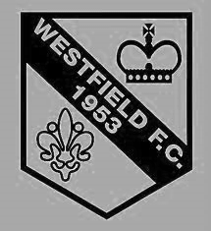
The Club was formed in 1953 as Westfield Boys Club playing in the Woking and District League and also running a youth team. From the start the Club had success in the competitions entered. Among the trophy’s won in the early years were the Surrey Youth Invitation Cup in 1953/54, the Surrey Junior Charity Cup in 1954/55 and 1955/56, the Surrey Junior Cup at the first attempt in 1955/56 and the Surrey Youth Cup in 1956/57.

Following several seasons in local league football the Club made the break into Surrey Intermediate Football using the present ground at Woking Park, Kingfield. Successes soon came and, after becoming League Champions and League Cup winners on several occasions in the subsequent seasons, the Club decided to apply for senior status.

The application was accepted in 1964 and after one season in the Parthenon League, Westfield met the necessary ground grading requirements and joined the Surrey Senior League.

Westfield’s future success in senior football sprang from their ability to attract the best local youngsters and they were successful in winning the Surrey Youth Cup again in 1966/67 and 1969/70 and the Surrey Youth Shield in 1969/70 and 1970/71. This talent matured and there followed three tremendous seasons for the senior side when they won the Surrey Senior League Cup in 1971/72, followed by the League and Cup double in 1972/73 and the League Championship again in 1973/74.

The Surrey Senior League was disbanded and reformed as the Combined Counties Football League in 1978 and Westfield became founder members and retained membership to date. Success, however, has been more difficult to achieve and in recent times the closest the senior team has come to honours was in 1989/90 when they lost the final of the Combined Counties League Cup to Hartley Wintney in extra time.

Season 2000/01 saw the Club enter the Carlsberg FA Vase for the first time, performing beyond expectations before losing in the Fourth Round to Ryman League Arlesey Town, on the way beating Wantage Town, Lewes and Bowers United.

Westfield continued to compete at youth level and they won the Combined Counties Youth League Cup in 1991/92 as well as being runners-up in the League.

Following the installation of floodlights in 1998 the U18 team joined the Southern Youth Floodlight League as members of the Western Division. The Club also run an U16 team playing in the West Surrey Youth League.

Centre page for results

Centre page for results



Every Opponent A-Z
Over the years we have played many, many different opponents. Exactly how many is a difficult question, as it all depends on your definition. Are Camberley & Yorktown different to Camberley Town, or are Epsom Town different to Epsom F.C. or Epsom & Ewell F.C.?

In my analysis I have classed them as the same team, and will work through them all from A to Z. Some we have played many times, whilst others we have met just once or twice. Enjoy!

Selsey: Played 1 - W0 D0 L1 - F0 A1 - PPG - 0.00

We have only made one trip down to the High Street Ground, home of Selsey, and this was for an F.A. Cup Preliminary Round tie on 29th August 2008, where quite frankly we were the victims of one of the worst cases of daylight robbery I’ve witnessed. The game started well for us as their keeper came out of his area and clattered into one of our players; being sent off after just twenty minutes. However, despite domination that was almost complete throughout, they got away after 70 minutes and hit a shot that looped up off a defender and the extremely strong wind did the rest. I was gutted for about a year after his one!

Selsey remain as they did then, in the Sussex League, now oddly renamed the Southern Combination League, but they are playing at Step Six these days, in Division One.

Sevenoaks Town: Played 1 - W0 D0 L1 - F0 A1 - PPG - 0.00

The story with Sevenoaks is very similar to our meeting with Selsey, although this match was much closer and with an F.A. Vase replay looming at Merland Rise after nearly 120 minutes of meandering boredom had failed to produce a goal, the visitors got a winner in the dying seconds.

They remain exactly where they were when we played them back in 2006/07, which is at Step Five in the Kent League, now of course renamed the Southern Counties East League, where their Greatness Park is shortly to become the latest venue to install a 3g surface.

Sheerwater: Played 4 - W2 D2 L0 - F8 A2 - PPG - 2.00 - Very Good

Despite being fairly local and for that matter, being just one division apart in the same league as us for the last ten years, we have only met on four occasions during our earlier visit to this level of football, back when it was named the Surrey Senior League during 1973/74 and the extremely successful season that followed it.

Our first meeting came on Saturday 13th October 1973 at West Street and we drew this match 0-0, also drawing the return at Sheerwater Recreation Ground 2-2 after leading 1-0 at the half; our scorers that day being Barry Jones and Tommy Tuite. It was draws like this against teams that were not as good as us really that cost us a chance to pip Westfield for the title, despite not losing any of our matches with them during that period.

The following season we made no mistake, winning the League at a canter as well as winning the League Cup and being defeated in the final of the Charity Cup and of course the F.A. Vase at Wembley Stadium.

We defeated Sheerwater twice by three clear goals, both home and away, although the away match was in fact transferred to West Street as the Sheerwater Recreation ground had started to be used for cricket by the 3rd May 1975. This couldn’t happen now as a children’s play area covers half of it. The matches produced six different scorers; Tommy Tuite obviously was one of these, and you might have been able to guess that Johnny Eales, Trevor Lee and Phil Walker also found the net. The other two were Alan Webb and Dave Worby, two far less frequent scorers.

Sheerwater moved to the Woking Athletic Club, next door to the Recreation Ground where without floodlights, they face a constant battle against F.A. demotion from Step Six. However, a new ground remains in the pipeline and they may still have more to give at a senior level.

Shepherds Bush: Played 2 - W1 D1 L0 - F9 A5 - PPG - 2.00 - Very Good

Shepherds Bush were a very well known club before World War One. They had been founder members of the Southern League in 1894 where they stayed until 1902 and in 1904 they built their own ground at a venue that still exists today, Loftus Road, the home of Queens Park Rangers. From 1908 until war was declared they were members at the top table of non-league football; the Isthmian League before disbanding in 1915 and losing their ground to QPR.

By the time we met, they had already reformed but whether they were connected to the original club is not clear, although they joined the London League in 1932 and were immediately placed in the top flight, so must have had some sort of pedigree to avoid the lower division.

We met for the first time at West Street on Saturday 12th November where they were handicapped by the loss of their keeper to injury after 32 minutes. They had been a goal ahead at the time but we recovered to win 6-2 as we ran away with it in the second half. The return came on New Year’s Eve 1932 where the papers say that our players struggled to adapt to the very small pitch at the Napier Sports Ground in Gunnersbury Lane, Ealing and we drew 3-3. They then finished second from bottom of the league but whilst Beckenham were relegated, the Bushmen disappeared entirely and I have no further record of the club with a very famous name.

Sheppey United: Played 2 - W0 D1 L1 - F2 A3 - PPG - 0.50 - Awful

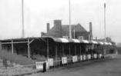
Sheppey United were a very old club and like Shepherds Bush were also founder members of the Southern League in 1894. Much of their life was spent in the Kent League with occasional sojourns back to the Southern League. Interestingly, Wikipedia advises one of its former players as Herbert Chapman, the famous and innovative Huddersfield Town and Arsenal Manager.

We met them while they were in the professional Kent League for an Amateur Cup Fourth Qualifying Round tie on 24th November 1956. We hadn’t made the First Round Proper since 1935 and hopes were high after a goalless draw ensured a replay the following Saturday at West Street.

Hopes were dashed in front of nearly 2,000 spectators at West Street as we lost 3-2, but the match will be remembered for Ernie Watkins scoring an equaliser, only for the referee to blow for full time, two minutes and ten seconds early according to the local papers! Maybe he had a train to catch! The club put in an official protest about the matter but it failed.

In their side that day was Derek Westley who would go on to become our club Captain in the early sixties but there the connections end and Sheppey lost their Botany Road ground and folded in 2001, but reformed and currently play in the Kent Invicta League at Holm Park.

The quaint old stand at Botany Road

Promotion Run-in
Following our recent home defeat against Hartley Wintney it is unlikely that we will now catch them, and the same goes for Ashford Town (Mx) or Camberley Town either.

Over the season I have heard a number of rumours that state it is very unlikely that this season’s Champions elect will get the required work completed on their ground that would enable them to take their place in Step Four. We are also aware that work has not yet started there.

We should find this out for certain in early April, but if it is proved to be true, then second place could prove extremely beneficial for whoever can finish in that position.

Right now, and on paper, we look like the slight outsiders of the three for that position. Here are the matches remaining.

For this analysis, I have sorted the league positions based on points per game,
inclusive of Tuesday’s (22nd March) results

Remaining Matches: Epsom & Ewell – Played 33 – Points 68

Today: Westfield (H) – 14th
28th March: Raynes Park Vale (A) – 9th
2nd April: Guildford City (A) – 11th
9th April: Badshot Lea (H) – 16th
12th April: AFC Hayes (A) – 17th
16th April: Camberley Town (H) – 3rd
23rd April: Hanworth Villa (A) – 6th
30th April: Ashford Town (Mx) (H) – 2nd
Unknown: Chessington & Hook United (A) – 20th

Remaining Matches: Camberley Town – Played 30 – Points 65

26th March: AFC Hayes (H) – 17th
28th March: Badshot Lea (A) – 16th
31st March: Farnham Town (A) – 12th
2nd April: Chertsey Town (A) – 19th
5th April: Redhill (H) – 21st
9th April: Raynes Park Vale (H) – 9th
12th April: Hartley Wintney (A) – 1st
16th April: Epsom & Ewell (A) – 4th
19th April: Raynes Park Vale (A) – 9th
23rd April: Guildford City (A) – 11th
26th April: Chessington & Hook United (A) – 20th
30th April: Sutton Common Rovers (A) – 18th

Remaining Matches: Ashford Town (Mx) – Played 34 – Points 77

26th March: Hartley Wintney (H) – 1st
28th March: Chertsey Town (A) – 19th
2nd April: Horley Town (A) – 5th
9th April: Guildford City (A) – 11th
16th April: Windsor (A) – 13th

21st April: Redhill (A) – 21st
23rd April: Sutton Common Rovers (H) – 18th
30th April: Epsom & Ewell (A) – 4th

If we add the league placings up and divide by the number of matches remaining we get the following, which shows the average position of the teams we are playing.

Epsom & Ewell: Total number: 98 / 9 = 10.89
Camberley Town: Total Number: 157 / 12 = 13.08
Ashford Town (Mx): Total Number: 92 / 8 = 11.50

Now using good old gut instinct, here are my predictions for how many points I believe each of the teams will get from those remaining matches. For this I have assumed that our matches against each other will end in draws.

Epsom & Ewell: Points won: 19 – Total Points: 87
Camberley Town: Points won: 27 – Total Points: 92
Ashford Town (Mx): Points won: 16 – Total Points: 93

This still places us fourth but doesn’t require much in the way of change to put us right up there. If we were to defeat Camberley and Ashford Town at home instead of drawing, then it would look like this:

Epsom & Ewell 91, Ashford 91, Camberley 90

It’s a big ask, but teams who win promotion rarely fall over the line. They get there with wins and you just never know in this game! Let’s just keep going and to use one of the oldest clichés of them all, take it a game at a time!

Player Profile – Number 18 – Bentley Graham
Our latest profile is from another of our newest players, Bentley Graham.

Age: 25


Position: Centre midfield

Club supported: Arsenal

Favourite Meal: Toad in the Hole

Favourite Film: American Gangster

Messi or Ronaldo: Ronaldo

Favourite Drink: Water

Favourite Ground played at: Upton Park

Best moment for Epsom: Scoring the winner on Tuesday at Farnham!

Describe the Gaffa in three words: Swears - Too - Much

Bentley’s Playing Stats: First Team Debut : 09/02/2016

Appearances: 8 - Sub: 1 - Total: 9 - Goals: 2

CCL Premier Division Club Directory
A.F.C. HAYES Telephone: 0208-845-0110 - Ground: Farm Park, Kingshill Avenue, Hayes, Middx. UB4 8DD - Colours: Blue and White Stripes/Blue/Blue

ASHFORD TOWN (Mx) Telephone: 01784-245908 - Ground: The Robert Parker Stadium, Short Lane, Stanwell, Middx. TW19 7BH - Colours: Tangerine & White Stripes/Black/Tangerine

BADSHOT LEA Telephone: 01252-320385 - Ground: Ash United FC, Shawfield Stadium, Youngs Drive, Shawfields Road, Ash, Hampshire. GU12 6RE - Colours: Claret/White/Claret

BEDFONT SPORTS Telephone: 0208-831-9067 - Ground: Bedfont Sports Club, Hatton Road, Bedfont, Middx TW14 8JA - Colours: Red & Black Hoops/Black/Red & Black Hoops

CAMBERLEY TOWN Telephone: 01276-65392 - Ground: Krooner Park, Wilton Road, Camberley, Surrey. GU15 2QW - Colours: Red & White Stripes/Blue/Red

CHERTSEY TOWN Telephone: 01932-561774 - Ground: Alwyns Lane, Chertsey, Surrey. KT16 9DW - Colours: Royal Blue & White Stripes/Royal Blue/Royal Blue

CHESSINGTON & HOOK UNITED Telephone: 01372-602263 - Ground: Chalky Lane, Chessington, Surrey. KT9 2NF - Colours: Blue/Blue/Blue

COLLIERS WOOD UNITED Telephone: 0208-942 8062 - Ground: Wibbandune Sports Ground, Robin Hood Way, Wimbledon. SW20 0AA - Colours: Blue & Black Stripes/Black/Black

COVE Telephone: 01252-543615 - Ground: Oak Farm Fields, 7 Squirrel Lane, Cove, Farnborough, Hampshire. GU14 8PB - Colours: Yellow/Black/Yellow

EPSOM & EWELL Telephone: 01737-553250 - Ground: Chipstead FC, High Road, Chipstead, Surrey. CR5 3SF - Colours: Royal Blue & White Hoops/Royal Blue/Royal Blue

FARNHAM TOWN Telephone: 01252-715305 Ground: Memorial Ground, Babbs Mead, West Street, Farnham, Surrey. GU9 7DY Colours: - Claret & Sky Blue /White/ Claret & Sky Blue

GUILDFORD CITY Telephone: 01483-443322 - Ground: The Spectrum, Parkway, Guildford, Surrey. GU1 1UP - Colours: Red & White Stripes/Black/Black

HANWORTH VILLA Telephone: 0208-831-9391 - Ground: Rectory Meadows, Park Road, off Hounslow Road, Hanworth, Middlesex. TW13 6PN - Colours: Red & White Stripes/Black/Black

HARTLEY WINTNEY Telephone: 01252-843586 - Ground: Memorial Playing Fields, Green Lane, Hartley Wintney, Hants RG27 8DL - Colours: Orange & Black/ Orange /Orange

HORLEY TOWN Telephone: 01293-822000 - Ground: The New Defence, Anderson Way, Court Lodge Road, Horley, Surrey. RH6 8SP - Colours: Claret & Sky Blue/Claret/Claret

KNAPHILL Telephone: 01483-475150 - Ground: Brookwood Country Park, Redding Way, Lower Guildford Road, Knaphill, Surrey. GU21 2AY - Colours: Red/Black/Red

SUTTON COMMON ROVERS Telephone: 01932-866386 - Ground: Sutton United FC, Gander Green Lane, Sutton, Surrey SM1 2EY - Colours: Yellow/Black/Black

RAYNES PARK VALE Telephone: 020-8540-8843 - Ground: Prince Georges Playing Field, Grand Drive, Raynes Park, London. SW20 9NB - Colours: Blue/Blue/Red

REDHILL Telephone: 01737-762129 - Ground: Kiln Brow, Three Arch Road, Redhill, Surrey RH1 5AG - Colours: Red and White Stripes/Black/Red

SPELTHORNE SPORTS Telephone: 01932-961055 - Ground: Spelthorne Sports Club, 296 Staines Road, Ashford Common, Ashford, Middx. TW15 1RY - Colours: Light & Dark Blue/Dark Blue/Light Blue

WESTFIELD Telephone: 01483-771106 - Ground: Woking Park, Kingfield Road, Woking, Surrey. GU22 9BA - Colours: Yellow/Black/Black

WINDSOR Telephone: 01753-860656 - Ground: Stag Meadow, St Leonards Road, Windsor, Berks SL4 3DR - Colours: Red/Red/Red

Latest Results Grid
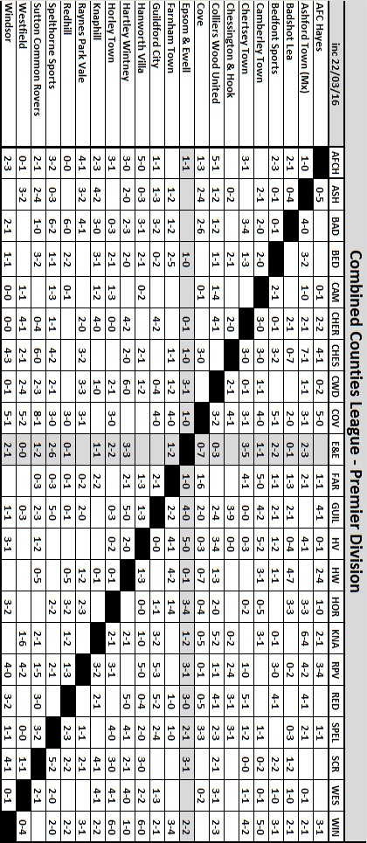

Respect Campaign
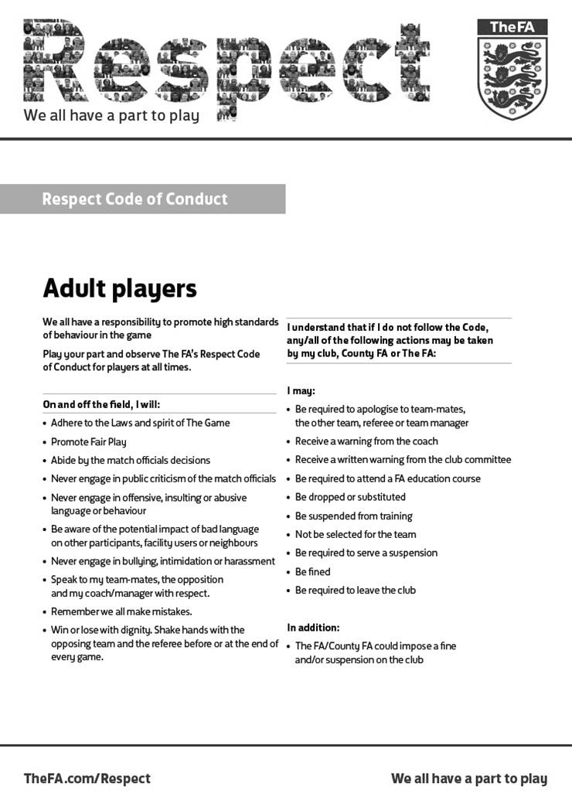

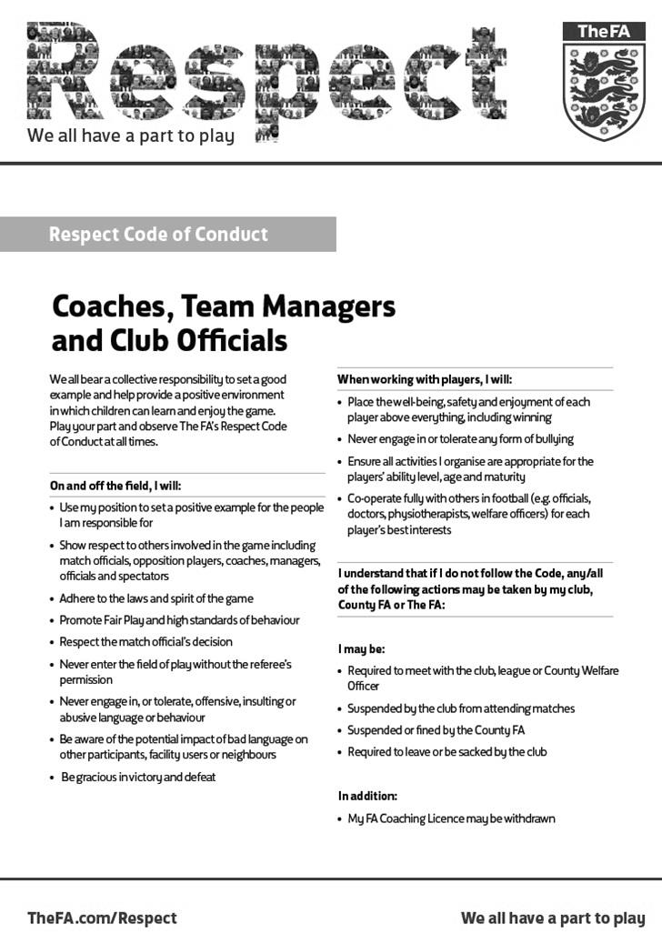

Birthday Corner

We have four player birthdays in March. Although Daryl Cooper-Smith has recently departed to play at Leatherhead, he remains on a dual registration so we may see him back one day. Daryl was 26 on the 5th of the month. Daryl made his debut on 3rd January 2015 against Windsor and has contributed regularly to the cause. He has of course, been suspended in recent months, which proved to be a costly learning exercise for both him and our club!


The following Saturday, 12th March was the birthday of our striker Tom Neale, who was also 26. Tom joined us from Worcester Park earlier in the season and has scored some important goals for us, not least the late winner at home to Chessington & Hook United the late equaliser at Hartley Wintney and the opener at Farnham on Tuesday.

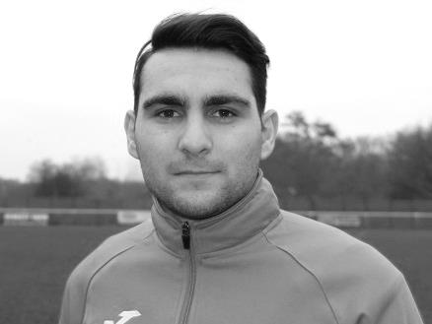

On Wednesday 16th March our International midfielder Savvas ‘Agi’ Panayiotou celebrated a milestone with his 21st birthday. A skilful and versatile player, he made his debut in the same match as Daryl and apart from a brief spell at Chipstead has been with us since.


Finally, on Saturday 19th of March Reisse Griffin had his birthday, becoming the third of our players to mark their 26th birthday this month! Reisse joined us at the start of the season from Cheam and was hampered originally by a knee injury that kept him out for a while. However, he has worked hard to get back to fitness and is now a regular performer in the side.

Congratulations chaps. We hope you all had great days!

Club Statistical History - (including Farnham Town (A) on 22/03/16):
League: Played: 2,828, Won: 1,160, Drawn: 537, Lost: 1,131
For: 5,198, Against: 5,020, GD: plus 178 - Win Ratio 41.02%

CCL only: Played: 407, Won: 186, Drawn: 79, Lost: 142
For: 732, Against: 634, GD: plus 98 - Win Ratio 45.70%

Cup and Other (inc Abandoned Matches):
Played: 1,097, Won: 518, Drawn: 128, Lost: 443 Abandoned: 8
For: 2,376, Against: 2,055, GD: plus 321 - Win Ratio 47.22%

Under Glyn Mandeville: Played 77, Won: 40, Drawn: 11, Lost: 26
For: 152, Against: 124, GD: plus 28 - Win Ratio 51.95%

Total: Played 3,925, Won: 1,678, Drawn: 665, Lost: 1,574, Aban: 8
For: 7,574, Against: 7,075, GD: plus 499 - Win Ratio 42.75%

First Senior Match: 30th August 1924.
Lost 1-3 vs Dorking at our home ground at the time of Horton Hospital Grounds.

First Match Programme Issued: 15th September 1923.
Won 4-0 vs West Norwood Reserves - Friendly match at Horton Hospital Grounds.

Number of Official Home Grounds: Six.

Alexandra Recreation Ground 1918-1922,
Horton Hospital Grounds 1922-1925,
West Street 1925-1993,
Merland Rise 1993-2010,
Moatside 2010-2012,
High Road 2012- present.

Record Win: 12/10/1935 - 13-1 v Reigate Priory (H) - Amateur Cup.

Record Defeat: 14/02/1948 - 0-14 v Chelmsford City Reserves (A) - London League.

Longest Serving Manager: 1) Adrian Hill 853 1982-1985 & 1990-2003
2) Pat O’Connell 466 1973-1982
3) Lyndon Buckwell 407 2006-2014
4) Ricky Kidd 190 1986-1990

Record Appearances: 1) Graham Morris 658 1990-2004
2) Nigel Bennett 630 1989-2005
3) Tommy Tuite 582 1973-1987
4) Ernie Watkins 419 1945-1960

Record Goal Scorers: 1) Tommy Tuite 391 1973-1987
2) Reg Marlow 254 1924-1936
3) Kyle Hough 192 2007-present
4) Jimmy Jones 148 1933-1945

Most Appearances in a season: Tony Coombe and Tommy Tuite - 59 in 1980/81.

Most goals in a season: Reg Marlow - 65 (at least) in 39 appearances in 1926/27.

Senior League Titles: 5 - 1925/26 Surrey Senior League - 1926/27 Surrey Senior League - 1927/28 London League - 1974/75 Surrey Senior League - 1977/78 Isthmian League Division Two

Friday football!
You may not think there has been much football on a Friday in recent years and you’d be right, with just two previous matches being played on that day in the last thirty years.

However, in the past, we used to play frequently on Good Friday as part of an Easter triple header. We would usually meet a local opponent on the Friday and Easter Monday with a third match being played on the Saturday in between. And they say it’s tough nowadays!

For today’s article I thought I would have a little look back through the archives of our previous Friday fixtures, all thirty-three of them.

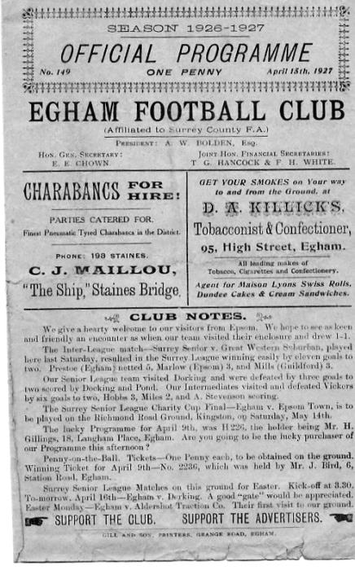
Our first ever Friday meeting actually came on a Boxing Day, way back in 1924. Many local matches were played back then on that date and we travelled to Pixham Lane, the old pre-war home of Dorking F.C. for a Surrey Senior League fixture, winning 3-2 with two goals from Reg Marlow and the other from one of the original members of the club, the ill-fated Jack Parr.

Our next match, which was the first of what would become 23 Good Friday fixtures, would take place at a well-known venue, the former home of Crystal Palace, the Nest. Palace had vacated it in 1924 and for the 1924/25 season Southern Railway, formerly known as Brighton Railway in the immediate post-war years had met us in a Surrey Senior League match.

Little is known about this fixture except that we lost the League match 2-1 on 10th April 1925 and I don’t even have our goal scorer or even an attendance yet, despite searching through a number of local papers!

The next Good Friday fixture would be played in front of 2,000 at Egham on 15th April 1927 as we visited their ground at Vicarage Road, for a Surrey Senior League fixture. (see programme pictured)

Our boys scored once in each half to win 2-0 (Jack Parr, Fred Watts) and we would return there the next month to defeat them again in completing a Cup win to go with our second straight League title.

On moving up to the London League in 1927/28 we found our next Good Friday fixtures were not what you would classify as local, as we visited Cray Wanderers (3-1), Beckenham (1-3) and then hosted Dagenham Town (0-0) in the next three years.

In 1930 we hosted Luton Amateurs in another Friday Boxing Day match, winning easily 8-1 at West Street, but at Easter we were off to Walthamstow Grange, losing 3-5 as the longer journeys continued.

Of course two local rivals Tooting Town and Mitcham Wanderers were regularly paired together while we set off on our travels. However, on 25th March 1932 we visited Tooting Town, winning 5-1 with Billy Williams scoring four times and from 1932/33 things would be different.

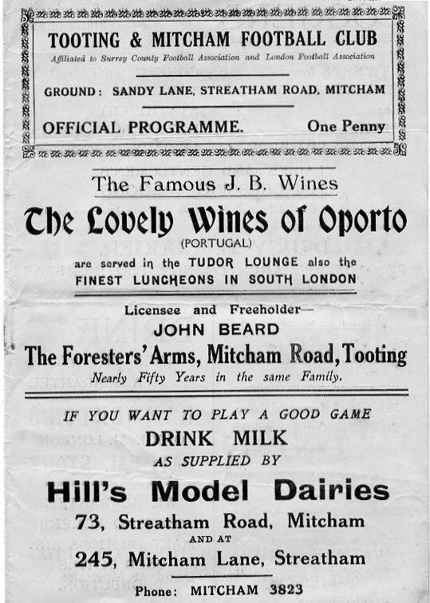
The reason for this was the two clubs merging into one, Tooting & Mitcham United for the 1932/33 season. It then made perfect sense for us to meet them over Easter and this would occur for the next five seasons, with us travelling to Sandy Lane on the Friday with the return at West Street on the Monday. When considering that these matches were all away from home, our record was good with three wins, a draw and a defeat from those matches. (see programme right from Good Friday 14th April 1933 - Note the name of the club. The “United” was not added until the 1933/34 season.

In 1937/38 Tooting & Mitcham would no longer be our opponents as they had moved up to the Athenian League; a position the Epsom club coveted and arguably deserved more as a result of their superior league places over the years. However, the ground at Sandy Lane was considered far more appropriate to the one at West Street with its smaller stand and already tired looking dressing rooms and we would have to wait until the sixties for our chance to come.

Our new local opponents were Walton on Thames FC, a forerunner of Walton & Hersham which formed directly after the war from the merger between them and Hersham. We again were scheduled to travel to Stompond Lane on the Fridays where

we drew in 2-2 in 1937/38 in front of 2,500 spectators and then lost 2-1 the following April, just before World War Two was declared.

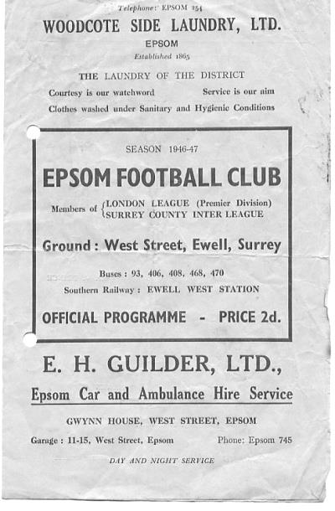
Following the war we had no regular opponent for Good Friday matches and in two of the three years we actually scheduled friendlies against Crawley in 1946 and a Crystal Palace ‘A’ team in 1948. In between we hosted Eton Manor on 4th April 1947 for a League match, losing 3-5. This was probably a re-scheduled match due to the atrocious winter that season which led to us playing matches at the end of May! (see programme left) Additionally, it was just our second home match on a Good Friday against fourteen away matches!

In our final season in the London League, 1948/49 we travelled to Guildford City’s Josephs Road ground where we lost 2-1 to their Reserves; future Manager Fred Chitty scoring our goal.

In 1949/50 we moved into the Corinthian League where we had another home match as Erith & Belvedere visited us, but they repeated their 3-0 win from earlier in the season.
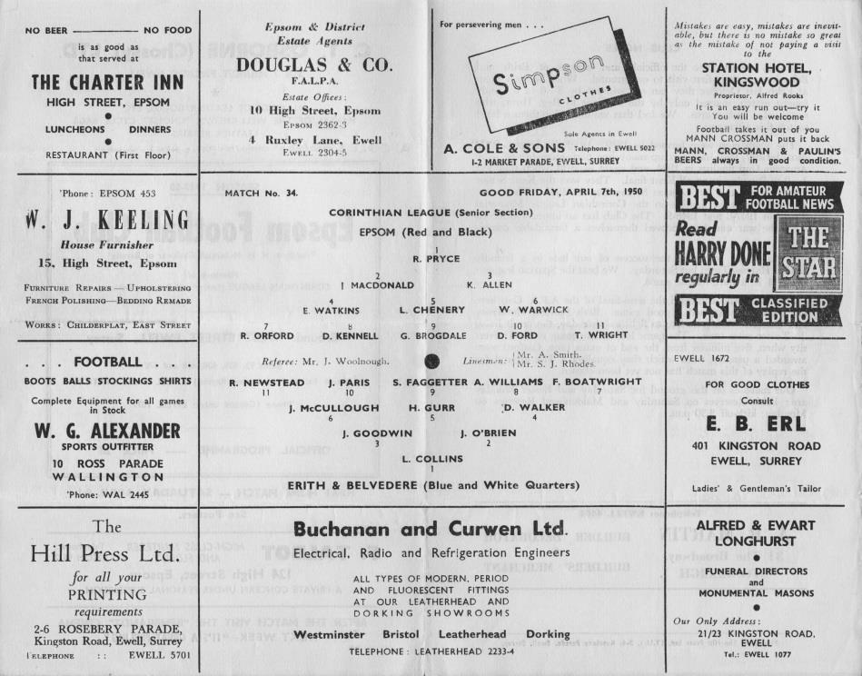

We had no Good Friday fixtures for the next couple of years as three games over the Easter holidays began to fade out of the fixture schedule. They still happened occasionally and in 1953 we suffered a bad 3-2 defeat at Worthing who were bottom of the League. Despite winning 7-1 the next day at home to Carshalton Athletic, the Robins still ended up with the title that year, while we had to settle for third place.

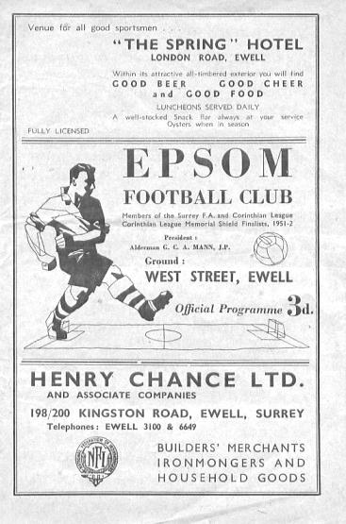
Boxing Day fixtures against Carshalton Athletic were still in fashion and occasionally, as was the case in 1953, a Christmas Day fixture took place, Ron Ruffell scoring in a 1-2 defeat at West Street (see programme left). We also met them in 1952 and in 1958 we had new Christmas opponents in Dorking who we drew 2-2 with on Boxing Day of that year.

We have played three more Good Friday fixtures since that time, in 1967 when we were held 0-0 by Marlow at West Street, in 1971 when losing 1-5 at home to Wingate and on 31st March 1972 when losing narrowly 2-1 at Grosvenor Vale to Ruislip Manor. Until today, this was the last time we had played on Good Friday.

There remain five other Friday fixtures since that last Easter match. The first of these occurred on 30th April 1976 and came right at the end of the Athenian League season. We made the journey to The Saffrons, home of Eastbourne Town for a 6pm kick off in our final Division Two fixture, knowing that barring a 17-0 defeat we would be going up. There was never a doubt as we won the match 6-0 with Tommy Tuite scoring a hat trick and other goals from Barry Denman, Keith Eshelby and Paul Butler.

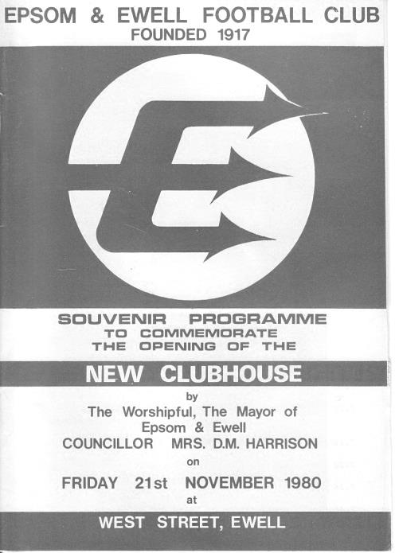
The next match was on 21st November 1980 and as was the case today, the opposition, in this case Lewes, agreed to bring the fixture forward from the Saturday as we officially opened our new Clubhouse. Tuite was on target again with two more in our 2-0 win. (see programme right).

It would be nearly five seasons before another Friday fixture, again right at the end of the season. By now an Isthmian

League Premier Division club, we had suffered a postponement at Bognor Regis earlier in the year and were then scheduled to visit on Wednesday 8th May but the Rocks drew their Sussex Senior Cup Final with Lewes and had to replay, moving our match back by two days. Adrian Hill’s final game of his first spell in charge of the club finished with a 2-1 win on the Friday 10th May 1985 with Tony Boorman and Steve Milton both scoring. For Milton this would be his final game, before going on to success at Croydon, Whyteleafe and eventually Fulham, while Boorman would return a decade later.

Our final two matches contain a low and a high. We were forced to bring our F.A. Cup tie forward a day due to ground sharing issues at Merland Rise in August of 1995 and Tooting & Mitcham United took full advantage, defeating us 4-0 to ensure we were the first team out of the F.A. Cup that season!

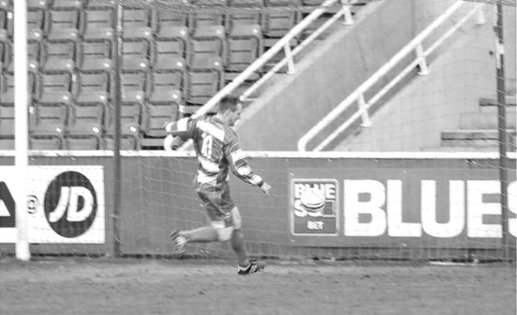
However, on Friday evening, 10th May 2013 everything dropped into place as we travelled to Farnborough’s Cherrywood Road ground for the Combined Counties League Cup Final. Having already knocked out the top two in Guernsey and Egham Town counted for little as we faced South Park in a match that most people felt was too close to call.

The first goal would be all important and when Ben Hayward hit the post after 20 minutes you wondered whether it would come back at us. However in the 29th minute Kyle Hough chased a through ball and just beat the advancing keeper to it, leaving him with the easy task of running the ball into the empty net (see picture below). Robbie Burns scored the second after 42 minutes as he lobbed the exposed keeper after a corner had not been cleared, and Sam Currie, a new player at the club that year, scored his first goal for us that night with a stunning drive into the far corner from Alex McGregor’s pass after 75 minutes.

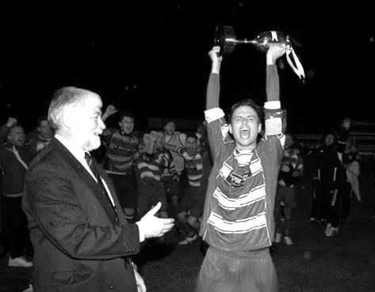
So there is your answer. Our last match on a Friday was just under three years ago. Doesn’t seem that long ago really!
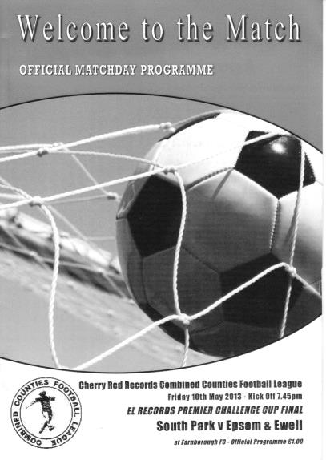
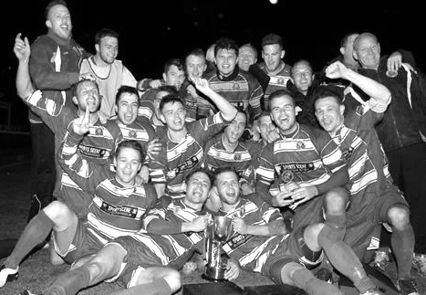

Pictures: (clockwise from top left)
1) Match programme from the League Cup Final
2) Captain Jamie Hatfield receives the trophy from League Chairman Chris Conlon
3) The team celebrate with the trophy
4) The Management Team get their turn

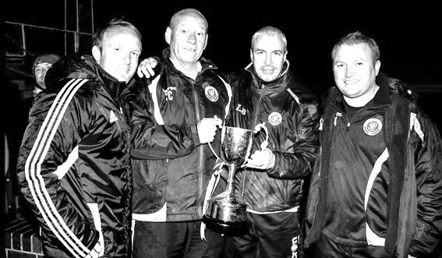

F.A. Vase
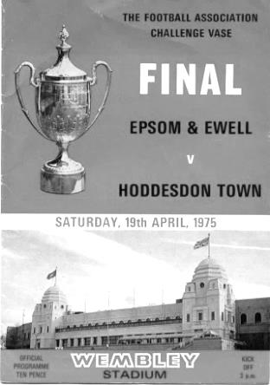
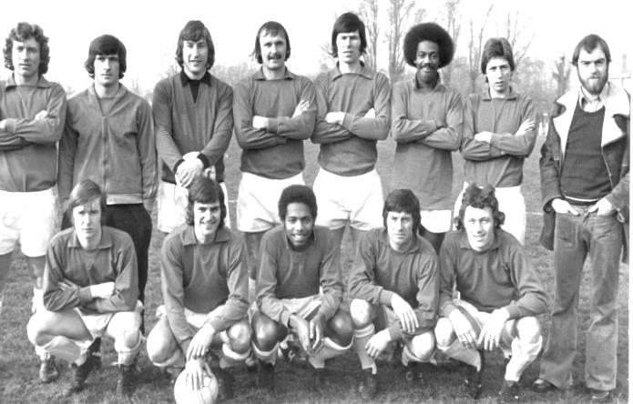
Fourth Round
Cleethorpes Town | 2-1 | Alvechurch
Hereford | 6-0 | Leicester Nirvana
Morpeth Town | 2-0 | North Shields
Coleshill Town | 1-3+ | Dunston UTS
AFC Wulfrunians | 2-3 | Nuneaton Griff
Sunderland RCA | 3-2 | Sleaford Town
Newton Aycliffe | 2-0 | Marske United
Bowers & Pitsea | 3-0 | Sutton Common Rovers
Kidlington | 3-2 | Knaphill
Newport IOW | 1-2+ | Ashford United
Moneyfields | 0-2 | Bristol Manor Farm
FC Romania | 1-2 | Camberley Town
AFC Dunstable | 0-3 | Salisbury
Berkhamsted | 4-2 | Hullbridge Sports
Hartley Wintney | 3-1 | Bradford Town
Bodmin Town | 1-3 | Ipswich Wanderers
Fifth Round
Ipswich Wanderers | 1-1+ r1-2 | Bowers & Pitsea
Sunderland RCA | 2-3 | Bristol Manor Farm
Camberley Town | 5-0 | Newton Aycliffe
Berkhamsted | 1-2 | Morpeth Town
Cleethorpes Town | 1-2 | Kidlington
Nuneaton Griff | 0-3 | Salisbury
Ashford United | 1-1+ r3-2 | Dunston UTS
Hartley Wintney | 1-4 | Hereford
Quarter Final
Hereford | 3-2+ | Camberley Town
Salisbury | 3-0 | Ashford United
Morpeth Town | 2-0 | Bristol Manor Farm
Bowers & Pitsea | 3-3+ r4-0 | Kidlington
Semi Final (two legs) 12-03-16 & 19-03-16
Hereford | 1-0 - 2-1 | Salisbury
Bowers & Pitsea | 2-2 - 1-2 | Morpeth Town

Surrey Senior Cup
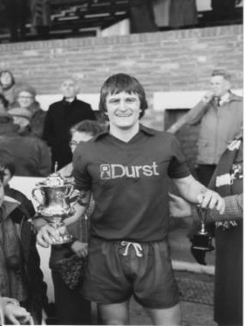
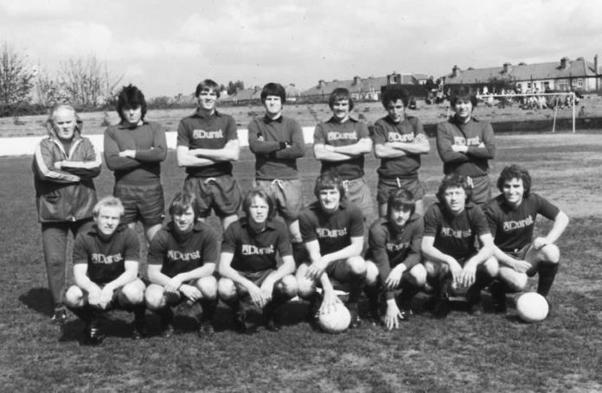
Second Round
Knaphill | 4-3 | Ashford Town (Mx)
Chipstead | 4-1 | Chessington & Hook United
Colliers Wood United | 1-3 | Whyteleafe
Corinthian Casuals | 1-1 CC 4-2p | Egham Town
Croydon | 3-3 F 3-2p | Farnham Town
Godalming Town | 1-0 | Guildford City
Horley Town | 2-2 BL 4-3p | Badshot Lea
Leatherhead | 3-0 | Carshalton Athletic
Merstham | 3-0 | South Park
Met Police | 3-2 | Dorking Wanderers
Molesey | 2-1 | Raynes Park Vale
Redhill | 0-3 | Tooting & Mitcham United
Sutton United | 3-0 | Walton & Hersham
Walton Casuals | 1-1 K 9-8p | Kingstonian
Westfield | 2-0 | Chertsey Town
Woking | 10-0 | Sutton Common Rovers
Third Round
Godalming Town | 1-2 | Tooting & Mitcham United
Godalming Town reinstated as Tooting & Mitcham United played an ineligible player
Whyteleafe | 6-0 | Farnham Town
Kingstonian | 0-1 @ LFC | Leatherhead
Badshot Lea | 1-5 | Merstham
Westfield | 1-4 @ Woking | Woking
Met Police | 0-1 | Molesey
Knaphill | 3-0 | Chipstead
Corinthian Casuals | 1-3 | Sutton United
Quarter Finals
Molesey | 1-3 | Woking
Knaphill | 0-1 @ Sutton | Sutton United
Whyteleafe | 0-3 | Godalming Town
Leatherhead | 0-4 | Merstham
Semi Finals
Sutton United | 1-3 | Godalming Town
Woking | 1-3 | Merstham

EL Records Premier Challenge Cup
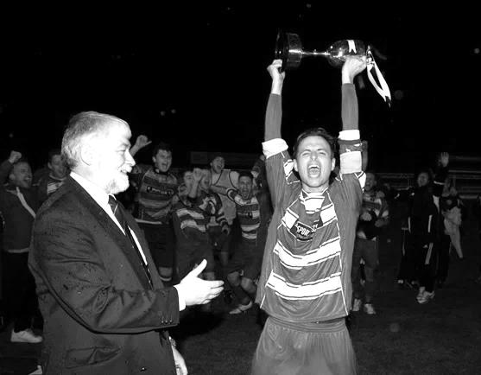
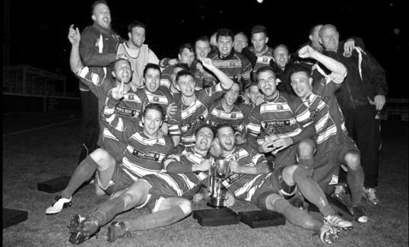
Second Round
Dorking Wanderers | 2-1 | South Park Reserves
Westfield | 1-0 | CB Hounslow United
Bedfont & Feltham | 1-5 | Colliers Wood United
Dorking | 0-3 | Knaphill
Badshot Lea | 2-4 | Spelthorne Sports
Hanworth Villa | 1-2+ | Chertsey Town
Ashford Town (Mx) | 2-1 | Epsom Athletic
Hartley Wintney | 4-2 | Horley Town
Banstead Athletic | 1-1+ | Epsom & Ewell
Epsom & Ewell won 7-6 on penalties
Sheerwater | 3-3+ | Frimley Green
Frimley Green won 8-7 on penalties
Farnham Town | 3-2 | Abbey Rangers
Camberley Town | 4-2 | Eversley & California
AFC Hayes | 0-1 | Banstead Athletic
Redhill | 3-0 | Sutton Common Rovers
Worcester Park | 1-5 | Chessington & Hook United
Cove | 1-6 | Cobham
Third Round
Camberley Town | 5-1 | Spelthorne Sports
Cobham | 3-0 | Frimley Green
Redhill | 0-2 | Farnham Town
Raynes Park Vale | 0-2 | Westfield
Epsom & Ewell | 0-3 | Ashford Town (Mx)
Colliers Wood United | 6-0 | Dorking Wanderers Reserves
Knaphill | 2-1 | Chertsey Town
Hartley Wintney | 0-1 | Chessington & Hook United
Quarter Finals
Camberley Town | 2-1+ | Colliers Wood United
Chessington & Hook United | 0-3 | Ashford Town (Mx)
Match played at Ashford Town (Mx) FC
Cobham | 2-0 | Westfield
Knaphill | 1-3 | Farnham Town

Salts Super Six Predictor
The Salts Super Six Predictor Competition is live again and the tickets are on sale at today’s game to the left of the gate. We recently had our third Super Six win but the jackpot is building up again already!

The competition is easy to play! To win, you simply need to predict the results of the six matches correctly from the three options, fill in the form and make sure it is back with our sellers before the deadline on the ticket.

If you are a club regular, you just need to place your name on the sheet, although if you aren’t, then we’ll need a contact number from you too. We will announce any winners on the website very quickly, so don’t worry we won’t miss you!
The jackpot is now at £115 and who knows how high it could go this time!

Please note that if there is more than one winner, the prize pot would be shared between the winners. All you need to do now is have a go, as many times as you like!

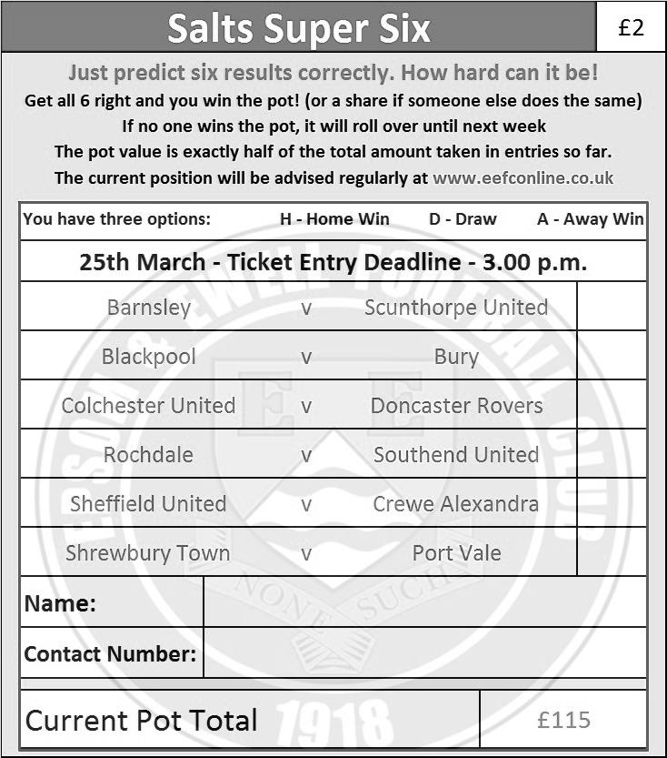

Good luck!

Epsom & Ewell F.C. Club History 1918 - 2015

We were founded in March 1918 as Epsom Juniors Cricket Club and played throughout the summer. In the autumn, Epsom Juniors F.C. came into being and played a handful of games from what is now known as Alexandra Recreation Ground. Competitive football followed as we entered the Surrey Junior League in 1919, and became founder members of the Sutton & District League in 1920.

A change of name in July 1922 to Epsom Town F.C. heralded the start of a very successful era. By now resident at the Horton Hospital Sports Ground, we were unfortunate to lose 2-1 after extra time at Dorking F.C.’s Pixham Lane ground to Caterham Mental Hospital in a replay of the Surrey Junior Cup Final. However, we won three other trophies that season, the Leatherhead Hospital Shield, the Sutton Hospital Cup, and the Epsom Hospital Cup. In addition, we also won the Sutton & District League, and under the forward thinking of their visionary Chairman Hugh Bradley, took the step into Intermediate Football, where we won the Southern Suburban League without losing a match. Senior football was granted as we were unanimously accepted into the Surrey Senior League for 1924/25, where we finished third.

In September 1925, the club relocated to the old Ewell F.C. ground at West Street, which was purchased through the generosity of our future President Robert Bradshaw. In 1925/26 the Championship of the Surrey Senior League was attained, and the following season, we defeated Egham 1-0 at Egham in the League Charity Cup to complete a League and Cup “double”.

Election to the London League followed, and the title was claimed in the first attempt in 1927/28. Unfortunately, we were unable to repeat this, instead finishing runners-up in 1931/32, 1932/33, 1934/35, 1936/37 and 1937/38. Cup Honours were limited, although in 1929 Redhill defeated us 3-2 in front of 4,600 at Guildford in our first Surrey Senior Cup Final, having seen off Wimbledon 4-1 in the semi-final!

The thirties were a very successful era, and we won the Surrey Charity (Senior) Shield in 1933 with an impressive 5-0 win over Woking at Kingfield. However, the proudest moment of our pre-war history was an appearance in the First Round Proper of the F.A.Cup in 1933/34. Woking, Nunhead, Tooting & Mitcham, Beddington Corner, and Leytonstone were defeated, and a crowd of 9,485 at the Lea Bridge Speedway Stadium witnessed a 4-2 loss against the hosts Clapton Orient. At the end of that season we changed our name to Epsom F.C.

In 1939 a newly formed team, Epsom Town (no connection to the earlier name) shared the ground with Epsom F.C. However, this arrangement was suspended when war was declared, and we folded for the duration. In the meantime, Club Chairman Charles Pettett threw in his lot with Epsom Town in an attempt to boost morale by keeping the football flag flying. It was successful, as that club competed continuously throughout the war years, winning the Surrey Combination in 1939/40, and reaching the Surrey Senior Cup Final in 1944, losing 3-1 to Tooting & Mitcham, at Sandy Lane. After the war, Epsom F.C. restarted, continuing in the London League and reclaimed West Street. Temporary homes were found for Epsom Town while they competed for a season in the newly created Corinthian League, but disbanded in 1946.

In 1949 we entered the Corinthian League ourselves, where in 1952 we reached the League Memorial Shield Final in 1952, going down 2-1 to Champions Hounslow at Eastbourne after leading at half-time. Things improved further with the signing of the former English Amateur International Pat Lynch from Hendon, finishing third in 1952/53, while in 1954 we reached the Surrey Senior Cup Final for the second time in our history, losing unluckily 2-0 to Corinthian Casuals in front of 6,159 at Selhurst Park. In 1955 we won the Surrey Senior Shield with a 1-0 win over Carshalton Athletic at West Street.

We appointed our first ever Manager, Kingstonian legend Doug Whitehead in 1955 and the Corinthian League double was almost achieved in 1956/57, but two losses in the final week, along with a 2-0 defeat in the Cup Final to Maidenhead United at Dorking ensured that we ended with neither, finishing fourth. However in 1960, we finally raised the Shield with a 2-0 revenge win over Maidenhead at Vale Farm, home of Wembley F.C.

In 1960 we changed our name once again to Epsom & Ewell F.C. This was not because of any merger with Ewell & Stoneleigh as is often quoted, but was an attempt to increase support across the whole of the Borough. In 1963 the Corinthian League merged with the Athenian and Delphian Leagues, and we were placed in Division One of the new structure, but the sixties were full of poor results and we were relegated in 1965.

Despite a string of managers, most notably ex-Leyton Orient winger Jimmy Smith, and Tony Williams, now famous for his creation of the F.A. Yearbooks, our fortunes did not improve significantly and further relegations were avoided in the early seventies by the benefit of re-election. However in 1973, despite “improving” to finish second from bottom, the Athenian League ran out of patience and cut us loose. This was unfortunate timing as

we had just cleared all of our debts, and in addition to a virtually new Committee, former Fulham player Pat O’Connell had taken over as Manager.

The Surrey Senior League took us in at the last minute, and the new squad, including young striker Tommy Tuite, won the League Cup, and the following season, 1974/75 achieved a second Surrey Senior League “double”. However, the season would always be remembered for reaching the Final of the inaugural F.A. Vase, where 9,500 saw the Blues edged out 2-1 by Hoddesdon Town at Wembley Stadium. The Athenian League welcomed us back, and promotion to the top flight was achieved in that first season. In 1976/77 we reached the Athenian League Cup Final, losing 1-0 at Chalfont St Peter.

For 1977/78 many clubs were invited to join the expanding Isthmian League, and we were placed in the new Division Two. Our first match under floodlights took place against Met Police, and the title was clinched the following April. In 1979/80 we won the Southern Combination Cup 7-2 over Hampton on their own pitch, where the opposition were blitzed by five goals from Tuite. The following season a new clubhouse opened at West Street, and we finally won the Surrey Senior Cup, defeating Woking 2-1 at Tooting & Mitcham, although we just missed out on promotion. In 1983/84 we clinched a spot in the Premier Division as runners-up, although this time we missed out in the Surrey Senior Cup Final, defeated 4-0 by Sutton United at Imber Court.

With Adrian Hill as Manager since 1982, we survived comfortably in our first season at the new level, but Hill’s departure to Croydon in 1985 started a decline. Much of the squad left with Hill, and new Manager Alan Webb had too much to do. We were relegated in 1986, and following Webb’s departure soon after, Player / Manager Ricky Kidd nearly but not quite saved us from our second straight relegation. Adrian Hill replaced Kidd for a second spell at the helm in 1990, but we were placed in the new Division Three in 1991 in league reorganisation following a finish one position below the required half way mark.

In 1993 a large chapter in our history ended as we left West Street and moved in as tenants of Banstead Athletic. The decade was largely one of frustration, although we did reach the Final of the Associate Members Trophy, losing 2-0 to Bedford Town at Hendon’s old Claremont Road ground.

In 2002 Adrian Hill took us back up to Division 1 South, where we topped the table for a month, eventually finishing 9th, but Hill’s retirement at the end of the season led to relegation a year later and in 2006 we were transferred into the Combined Counties League Premier Division. In October 2006 Lyndon Buckwell, a former player became our new Manager, and in his first full season (2007/08) we were back in the top ten. In 2008/09 we exceeded this achievement and finished in fourth place after heading the table for a few months. In 2009/10 the club recovered from a slow start to finish fifth and also reached the last 32 of the F.A. Vase for the first time in 21 years, bowing out 3-2 in Northamptonshire to Long Buckby. In April of 2010 we terminated our seventeen-year ground sharing agreement with Banstead Athletic and spent two unspectacular seasons at Merstham F.C. before relocating to High Road, home of Chipstead F.C. for the 2012/13 season.

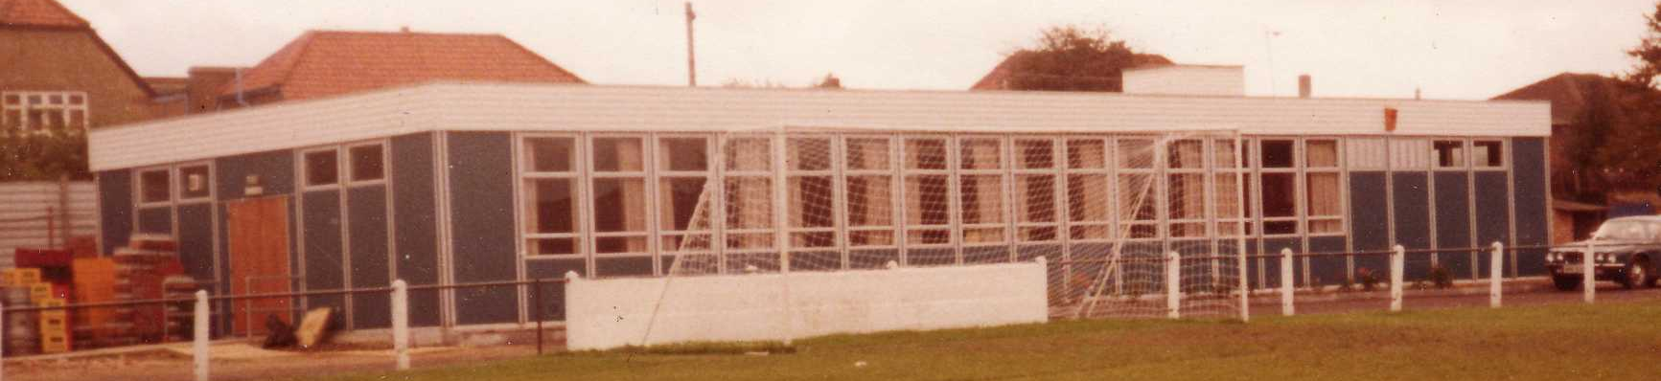
The season brought significant playing success as a slow start was followed by a spectacular run of form, including a club record 12 straight League wins, which put us at the top of the table for over a month before a tough run in resulted in a final position of fifth. However, any disappointment there was tempered by the club’s first silverware since 1981 when we defeated South Park 3-0 at Farnborough to win the Combined Counties League Cup. Lyndon also marked 300 games in charge of the club in early 2013. On a sadder note, 2012/13 also marked one thousand games and twenty seasons since we left West Street.

We carried our fine form into 2013/14 and led the league with eight straight wins but couldn’t hold on and had to settle for third place, our highest league finish since 1984, but the following season Lyndon Buckwell departed and Glyn Mandeville and new Assistant Matt Smith steered the club to seventh place, despite a substantial budget cut, and we continue at High Road for 2015/16.

Meanwhile, the search continues for a new ground back in the Borough…..

Player Sponsorship
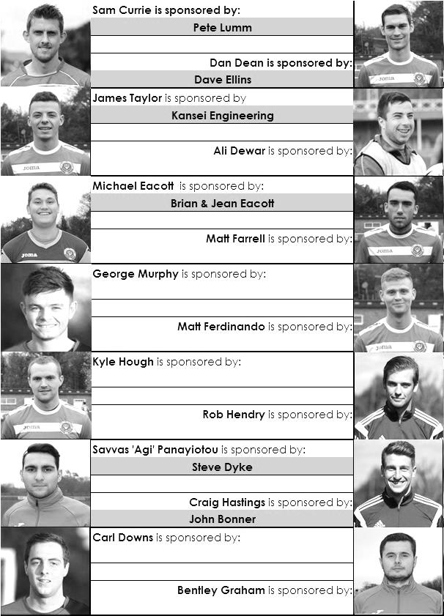

Here is the current list for the 2015/16 season showing all of our players and Management that are currently available for sponsorship this season.

Sponsorship costs just £40 and it is easy to do. Just select a player who has not been previously sponsored and let a Committee Member know that you would like to sponsor them. Beware though. Until we have received the money it is possible for someone to jump in front of you, so don’t delay, sponsor today!
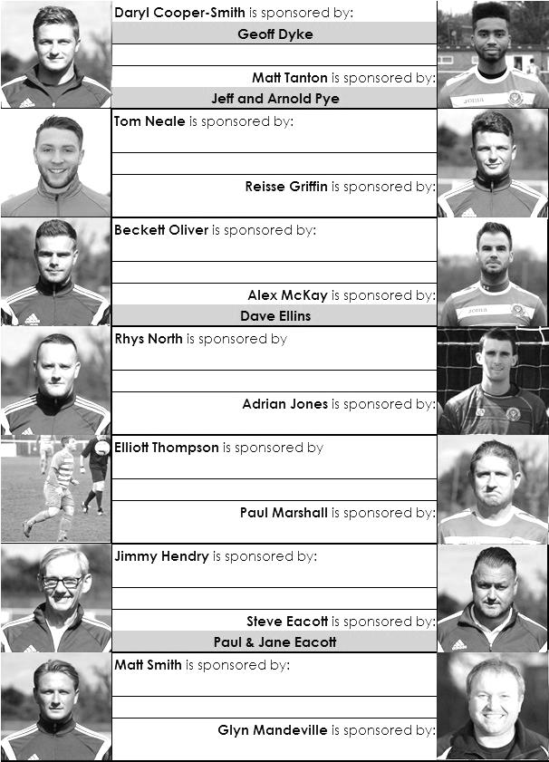

Match and Ball Sponsorships – 2015/16
Opponent | Date | Match Sponsor | Match Ball Sponsor
Hoddesdon Town | 18/07/15 | Geoff Dyke
Windsor | 08/08/15 | Club President - Stella Lamont
Erith & Belvedere (FAC) | 16/08/15 | Committee Member - Mike Lovett
Raynes Park Vale | 31/08/15 | EEFC Management Committee
Colliers Wood United | 08/09/15 | Bookham Building Shop – www.buildingshop.co.uk
AFC Hayes | 19/09/15 | John Bonner
Farnham Town | 26/09/15 | Ezara and Inaya Beddoe – our youngest supporters!
Chertsey Town | 17/10/15 | Club Media Officer – Richard Lambert
Dorking Wanderers (SSC) | 20/10/15 | Tony Ferdinando
Chessington & Hook United | 07/11/15 | Paul Merritt
Hanworth Villa | 21/11/15 | Maggie Beddoe
Guildford City | 05/12/15 | Pete Lumm
Sutton Common Rovers | 19/12/15 | Marvin Hough
Ashford Town (Mx) (LC) | 12/01/16 | Pete Beddoe & Steve Dyke
Redhill | 02/02/16 | David Lawton
Bedfont Sports | 13/02/16 | Bookham Building Shop – www.buildingshop.co.uk
Hartley Wintney | 23/02/16 | EEFC Management Committee
Horley Town | 27/02/16 | Jeff and Arnold Pye
Spelthorne Sports | 01/03/16 | In memory of Chris Henry
Knaphill | 12/03/16 | Marvin Hough
Cove | 15/03/16 | Mark & Carmel Murphy
Westfield | 26/03/16 | Nathan Lambert
Badshot Lea | 09/04/16 | Tony Coome
Camberley Town | 16/04/16 | Marvin Hough
Ashford Town (Mx) | 30/04/16 | Club President - Stella Lamont
Ashford Town (Mx) | 30/04/16 | Brian Eacott | Steve Dyke
For League, League Cup and Surrey Senior Cup Matches:
Match sponsorship - £40.00 Match ball sponsorship - £25.00. Combined £55.00.

We can still take more sponsors – Any game can have more, or why not sponsor a player?

Sponsorship includes: ( x2 for match, x3 for match and ball )

Admission, programmes, hospitality, advertising and mascot for the day (if required ).
If you are interested, just speak to a Committee Member, or drop me an email at: richard.c.lambert@gmail.com


We also thank our Kit Sponsors INTERCEM

Do the Conga!
Club Treasurer Steve Dyke is taking on another challenge for charity next Saturday April 2nd before our game with Guildford City. Steve is attempting to break
the World Record for the longest distance travelled by a conga line in aid of the charity he works for Mid Surrey Mencap. He explains why here:

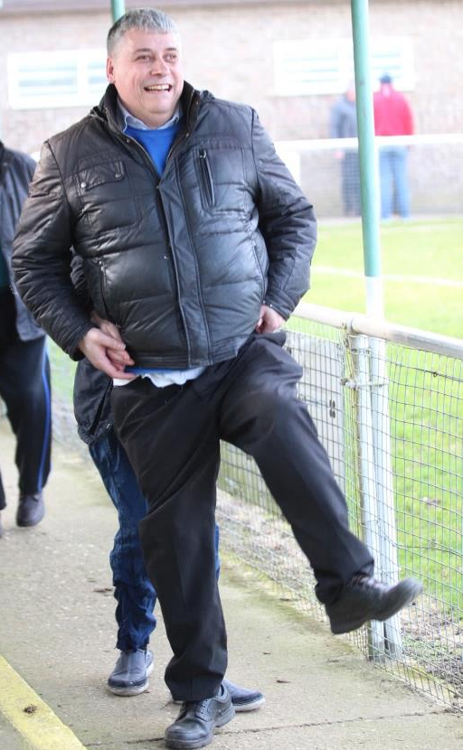
The idea of a longer conga came to me at last Summer’s Mencap barbecue. "We have these social events at Mencap where the raffle goes on forever. As I was comparing it, I speculated that we may all have just taken part in the world’s longest ever raffle!

That night I looked it up in the Guinness Book of Records and I found the Conga one. The existing record is 3 1/2 miles (5.1 km) and I thought we can do that, it's about the distance between Epsom and Leatherhead, the two main towns on our patch. When we looked into it with the Records book people, they insisted it had to be done on a measurable track.

This is why we're doing it at the Spectrum as they have an athletics track we can use. The people at Guildford City have been very helpful and positive about the idea and it is being run as a partnership event with Guildford City's partner charity the Halow Project, which runs services for young people with learning disabilities in the Guildford area so both clubs partner charities are being helped.

The conga will start at 12 .00 and we hope to complete 6000m in about 1 1/2 - 2 hours so the conga participants can rest and watch the match afterwards. If Mo Farah can do 6000m in about 15 minutes we're aiming for 8 times as slow as Mo.

Steve is raising money to help pay for this year’s Playscheme for disabled children which he is the manager of. He can be sponsored by donations in person or online at:

https://crowdfunding.justgiving.com/stephen-dyke

If anyone would like to participate they don't have to do the whole 6000m as long as a core of people manage it we can run rolling substitutions. The more the merrier!

The picture above shows Steve getting a bit of training in at Chipstead!

Combined Counties League – Premier Division
Good Friday, 25th March 2016 - Kick-off 1.00 p.m.
Epsom and Ewell  (Royal Blue & White hoops) | V |  | Westfield  (Yellow/Black/Black)
Squad | NUMBERS
Michael Eacott |  |  | Arjuna Adlam
© Sam Currie |  |  | Luke Beale
Matt Tanton |  |  | Rob Parrott
James Taylor |  |  | Oliver McAleese
Craig Hastings |  |  | Phil Moore
Bentley Graham |  |  | Matt Steer
Savvas ‘Agi’ Panayiotou |  |  | Jack Church
Matt Farrell |  |  | Pat Kirby
Kyle Hough |  |  | Doug Noble
Tom Neale |  |  | James Mariner
Reisse Griffin |  |  | Dale Burnham
Elliott Thompson |  |  | Matt Jackson
Dan Dean |  |  | Alex Pitt
George Murphy |  |  | Miguel Anderson
Rob Hendry |  |  | John Brawley
Alex McKay |  |  | Haluna Masembe
Adrian Jones |  |  | Ben Placito
Rhys North
Beckett Oliver
Carl Downs
Matt Ferdinando
Glyn Mandeville | MANAGER |  | Dan Snare
Matt Smith | ASSISTANT |  | Dave Powell
Steve Eacott / Alex McKay / Jimmy Hendry | COACHES / PHYSIO |  | Mike Brawley, John Steerwood
REFEREE: M.Hounsell (Camberley)
ASSISTANTS: R.van Niekerk (Sutton), C.Griffith (Thornton Heath)
Today’s Match and Match Ball are sponsored by one of our youngest supporters, Nathan Lambert who will be 8 on Saturday 2nd April

OUR NEXT VISITORS TO HIGH ROAD ARE:
Badshot Lea
Saturday 9th April 2016 - Kick-off 3.00 p.m.
Combined Counties League – Premier Division

